**Q1**

**Analyze the scalability and cloud transformation challenges of HealthSecure Inc.**

HealthSecure Inc., a prominent healthcare organization with an extensive network of hospitals, clinics, and research facilities across the country, faces unique challenges in expanding its operations to meet the growing demands of patient care. As the volume of sensitive patient data and the complexity of healthcare services continue to increase, HealthSecure Inc must. Address critical scalability issues to maintain high levels of service and compliance. This requires a strong, flexible and efficient infrastructure capable of supporting the needs of the expanded organization. Cloud transformation offers a compelling solution to these challenges, providing scalable, secure, and cost-effective infrastructure capabilities. This analysis explores the scalability challenges faced by HealthSecure Inc., assesses how cloud transformation can mitigate these challenges, and assesses key business processes necessary for a successful cloud migration strategy.

#### **Managing the exponential growth of patient data**

HealthSecure Inc., being a leading healthcare institution, is one of the largest medical service providers in the country, facing significant challenges related to managing the exponential growth of patient data. As the network of hospitals, clinics, and research facilities expands, the volume of medical records, personal information, and treatment history is increasing exponentially. This increase is putting pressure on existing storage and processing infrastructure, causing slow data access, increased downtime, and higher costs for maintaining and expanding physical data centers. To overcome this challenge, I can As a cloud engineer at SecureTech Solutions, leverage advanced cloud solutions to ensure efficient data storage and quick access, while implementing robust security measures such as encryption and access controls to protect sensitive information.

#### **Facing volatile demand for healthcare services**

Healthcare services are characterized by significant changes in demand, influenced by factors such as seasonal diseases, epidemics and unexpected medical emergencies. This change presents a major challenge for HealthSecure Inc. Existing infrastructure may not be flexible enough to handle this sudden change in demand, leading to performance bottlenecks and reduced quality of service. In addition, the lack of real-time data processing capabilities hinders the organization's ability to make timely informed decisions, negatively impacting patient care and operational efficiency. To deal with this challenge, we can improve the resilience of cloud infrastructure through automated scaling technologies and the use of cloud services that Supports real-time data processing.

#### **Compliance with regulatory standards**

HealthSecure Inc. must.Comply with strict regulatory requirements such as the HIPAA Health Insurance Act, which imposes strong data protection and privacy standards. Ensuring compliance with these regulations while managing scalable infrastructure is a complex and resource-intensive task. The company needs to implement advanced security measures, regular audits, and ongoing monitoring to ensure compliance, which increases the pressure on IT resources. I can suggest scalable compliance solutions by implementing strong data encryption, access controls, and audit trails to enhance the security of data and facilitate compliance with regulatory requirements.

#### **Integration with diverse healthcare systems**

HealthSecure Inc. oversees has an extensive network of hospitals, clinics and research facilities, requiring seamless integration with different healthcare systems to facilitate efficient operations. Integration with these systems is a major challenge due to the wide variety of technologies used over the network. This complexity can lead to data silos and interoperability bottlenecks, hindering the delivery of coordinated and comprehensive healthcare services. To overcome this challenge, we can use API gatewaysPowerful middleware platforms to facilitate seamless data exchange and standardization of data formats and protocols.

#### **Improved performance and reliability**

HealthSecure Inc. Ensure medical professionals and patients have access to critical healthcare information in a timely manner, requiring reliable cloud performance. The challenge here includes maintaining optimal performance and high reliability in light of the increasing demand for healthcare services. Inadequate performance can delay access to critical information, compromising patient care outcomes and organizational productivity. To overcome this challenge, I can suggest using performance improvement techniques such as adjusting resource allocation and using them efficiently, and scaling resources dynamically, Deploy redundancy and failover mechanisms to enhance reliability.

#### **Manage financial costs effectively**

One of the major challenges faced by HealthSecure Inc. It is the management of costs associated with expanding infrastructure and expanding operations. A delicate balance must be struck between meeting growing infrastructure needs and controlling expenses to avoid budget overruns and financial instability. Inefficient cost management practices can lead to budget overrun, waste of resources, and financial instability. To overcome this challenge, I can suggest using cost-effective pricing models, implementing cost-saving measures such as tagging resources to track expenditures, and negotiating favorable contracts with service providers. Cloud for cost savings.

#### **Assess how cloud transformation can address these challenges**

#### **Managing the exponential growth of patient data**

Cloud transformation can effectively address the challenge of exponential growth of patient data by providing a flexible and scalable infrastructure. Thanks to cloud services, HealthSecure Inc. Store large amounts of medical data without having to invest in expensive physical data centers. Cloud storage enables the company to quickly access data and improve response times, contributing to improved patient care. In addition, cloud services provide advanced security measures such as encryption and access controls, ensuring the protection of sensitive data and compliance with regulatory standards such as HIPAA.

#### **Facing volatile demand for healthcare services**

Cloud infrastructure has the ability to dynamically adapt to changes in demand for healthcare services. The company can take advantage of automatic expansion technologies, which allow resources to be allocated as needed and based on actual demand. This approach helps avoid performance bottlenecks and ensure the delivery of quality services even in times of increased demand. The ability to process real-time data also enhances the company's ability to make informed and quick decisions, contributing to improved care Patients and operational efficiency.

#### **Compliance with regulatory standards**

Cloud transformation can significantly contribute to improving compliance with regulatory standards by providing a secure environment and accurate data monitoring. Cloud services enable the implementation of robust security measures such as strong encryption, advanced access controls, and comprehensive audit trails. These services also provide tools to monitor compliance and regularly carry out audits, facilitating compliance with regulatory requirements such as HIPAA. This approach reduces stress on IT resources and ensures the protection of sensitive data.

#### **Integration with diverse healthcare systems**

Cloud transformation makes it easy to integrate with different systems within the HealthSecure Inc. network. Thanks to the use of powerful API gateways and middleware platforms. These technologies enable seamless data exchange between diverse systems, removing barriers and standardizing data formats and protocols. This effective integration helps improve operational processes and deliver integrated and comprehensive healthcare services. This approach also enhances the ability to securely exchange information between different healthcare providers.

#### **Improved performance and reliability**

Cloud infrastructure is capable of improving performance and reliability through technologies such as dynamic resource allocation and efficient adjustment of their usage. HealthSecure Inc. Leverage these technologies to ensure that the necessary resources are provided when needed, contributing to improving the performance of health applications and services. In addition, the cloud enables the deployment of redundancy and failover mechanisms, enhancing system reliability and ensuring service continuity even in emergency situations.

#### **Manage financial costs effectively**

Cloud transformation is an effective financial cost management solution, where a company can use usage-based pricing models, allowing only the costs of used resources to be paid. These models contribute to cost savings compared to large investments in physical infrastructure. Cost-saving measures such as marking resources can also be implemented to track expenses and identify areas for improvement. Favorable contracts can also be negotiated with cloud providers to achieve additional savings and ensure the company's financial sustainability..

**Cloud transformation can address many of the challenges HealthSecure Inc. faces. By providing flexible, secure and scalable infrastructure, improving patient care, ensuring regulatory compliance and achieving cost savings.**

**Key business processes to consider when assessing cloud viability**

#### **.1 Patient Data Management**

Patient data management includes all activities related to the collection, storage, retrieval and analysis of patients' medical data. This data includes electronic health records, treatment history, test results, and prescribed medications. The main goal is to ensure that accurate and comprehensive information is provided for physicians and healthcare providers to make informed decisions about patient care. The effectiveness of this process depends on a sophisticated data management system that can handle large amounts of information securely and efficiently.

**Cloud migration:** Cloud migration in patient data management can enhance HealthSecure Inc. capability.to provide advanced health care. The cloud can provide a flexible and scalable infrastructure that enables quick access to patient data from anywhere, anytime. In addition, security can be improved through the use of advanced encryption technologies and access controls.

**Positives:**

* **Quick Data Access:** Allows instant access to patient information from anywhere, anytime, contributing to improving the efficiency and effectiveness of healthcare. Doctors and nurses have access to medical records quickly to make more accurate treatment decisions in a timely manner.
* **Security and encryption:** Offer high levels of security to protect sensitive data through the use of advanced encryption technologies and access controls. This helps reduce the risk of data breaches and ensure compliance with regulations such as HIPAA.
* **Scalability: The** ability to adapt to increasing data volumes without the need for significant infrastructure investments, allowing the organization to scale efficiently as the patient database grows.

**Cons:**

* **Cost:** Costs for moving to the cloud and managing data in the cloud can be high, especially at the outset as they include infrastructure costs, training, and sometimes ongoing service costs.
* **Internet connectivity:** Access to data in the cloud relies heavily on the internet connection, which exposes the process to problems in the event of interruptions or impaired connections, which can negatively affect the provision of timely care.
* **Regulatory Compliance:** The need for careful and continuous scrutiny to ensure that all procedures comply with regulations. This may require additional resources to ensure full compliance with health laws and standards.

#### **2. Billing**

Billing includes all activities related to the preparation and issuance of invoices for patients or insurance companies. This process includes recording the services provided, calculating costs, preparing final invoices, and ensuring that invoices are paid on time. The effectiveness of this process depends on an accurate and organized system that can track all financial transactions easily and accurately.

**Cloud migration:** Moving to a cloud billing system can improve the accuracy and speed of invoicing. The cloud can enable the integration of billing systems with other management systems such as patient data management and accounting systems, resulting in fewer human errors and improved overall efficiency.

**Positives:**

* **Accuracy:** Improve billing accuracy by reducing human errors, reducing financial issues related to incorrect invoices and contributing to improved customer satisfaction. This can also reduce the need for billing corrections and audits.
* **Speed:** Accelerate the invoicing process, resulting in improved cash flow and financing. Fast and accurate billing helps the organization maintain a healthy cash flow and ensure that the necessary financial resources are provided for day-to-day operation.
* **Integration: The** ability to integrate billing systems with other systems such as patient data management and accounting to improve overall efficiency and reduce manual redundancy in data entry. This leads to better coordination between different departments of the organization.

**Cons:**

* **Security:** The need to ensure the security of sensitive financial data, as invoices include sensitive financial and personal information that can be the target of cyberattacks. Advanced security measures must be taken to protect this data.
* **Cost: The** cost of moving to the cloud and managing its billing can be high, especially when considering the costs of new infrastructure, software, training, and ongoing maintenance.
* **Training:** The need to train employees on new systems, which requires additional resources and takes time to ensure that everyone can use the new system efficiently. There may be resistance to change among employees, which calls for additional change management efforts.

**3. Scheduling treatment**

**Process Explanation:** Treatment scheduling involves arranging patient appointments, including medical visits, therapy sessions, and other medical procedures. This process requires careful coordination between different healthcare providers to ensure timely and efficient treatment is provided. The success of this process depends on a flexible and efficient scheduling system that can handle multiple appointments and their changes easily.

**Cloud migration:** Moving to a cloud treatment scheduling system can significantly improve the efficiency of this process. Cloud systems allow healthcare providers to access appointment schedules from any device, at any time, making it easier for patients to book and manage appointments. Smart systems can also analyze usage patterns and make recommendations to improve resource allocation.

**Positives:**

* **Efficiency:** Improve the efficiency of appointment scheduling through intelligent schedule management systems, reducing waiting times and contributing to an improved patient experience. This enables good integration of resources and better coordination of appointments between doctors and patients.
* **Remote access:** Allows patients to book and review appointments online, facilitating access to healthcare and improving the overall patient experience. Patients can choose times that are convenient for them and change their appointments easily.
* **Data analysis:** Use data to analyze usage patterns and identify the busiest time periods, helping to optimize resource allocation and reduce waiting times. These analytics can provide better visibility to optimize scheduling processes and allocate resources more effectively.

**Cons:**

* **Complexity in integration:** Integrating a cloud treatment scheduling system with existing systems can be complex and require additional time and costs. It may require significant modifications to existing infrastructure and staff retraining.
* **Technical issues:** Technical issues such as malfunctions or slow performance can affect appointment scheduling, which can lead to delays in healthcare and cause inconvenience to patients.
* **Training:** The need for comprehensive training of employees to ensure efficient use of cloud systems, which calls for allocating additional resources and increasing effort and time to ensure that everyone is able to use the system efficiently.

#### **4. Medical research**

Medical research includes all activities related to the collection and analysis of scientific data, the experimentation of new treatments, and the analysis of research results. This process aims to improve medical knowledge and develop new treatments for diseases. The effectiveness of this process depends on quick and accurate access to large amounts of data, and the use of advanced analysis tools.

**Cloud migration:** Cloud migration in medical research can enhance the efficiency and speed of data collection and analysis. The cloud can provide enormous computational resources and advanced analytical tools, enabling researchers to process large amounts of data more quickly and accurately.

**Positives:**

* **Data access:** Provide fast and reliable access to large amounts of scientific data, accelerating the pace of research and development in the medical field. Researchers can access data from anywhere, anytime, facilitating international collaboration.
* **Computational power:** Deliver significant computational resources to efficiently process and analyze data, enabling researchers to easily perform complex analyses and simulated experiments. This can lead to faster and more accurate scientific discoveries.
* **Collaboration:** Enhance collaboration between researchers by easily sharing data and tools via the cloud, contributing to improving the quality of research and sharing knowledge between different research institutions.

**Cons:**

* **Security:** The need to ensure the security of sensitive research data, as research includes important data that could be the target of cyberattacks. Advanced security measures must be taken to ensure that this data is protected from unauthorized access.
* **Cost:** Costs of moving to the cloud and managing data in it can be high, which can be challenging for limited research budgets. Costs and benefits must be carefully analyzed to ensure that you make the most of available resources.
* **Compatibility:** Ensure that all existing research tools and systems are compatible with cloud infrastructure, which may require significant modifications and restructuring of some existing systems. It may take additional time and effort to ensure full compliance.

**HealthSecure Inc. confronts.Significant scalability challenges that can be effectively addressed through cloud transformation. By leveraging the power and resilience of cloud platforms, an organization can enhance its data management capabilities, ensure compliance with regulatory requirements, and improve overall operational efficiency. Considering key business processes such as patient data management, billing, treatment scheduling, medical research, and disaster recovery strategies in cloud feasibility assessment will ensure a comprehensive and successful cloud migration strategy that supports the organization's long-term goals and objectives.**

**Q2**

**Cloud System Feasibility Study for HealthSecure Inc.**

**Operational feasibility**

**Analysis of current operational processes:** The first step in the operational feasibility assessment includes a comprehensive review of HealthSecure Inc' s current operations.To identify deficiencies and areas for improvement. This analysis will cover how sensitive medical data is managed, such as patient health records and personal information. Understanding these processes will ensure that the new system effectively addresses current challenges and enhances operational efficiency.

**Evaluate solution integration:** Assessing the extent to which the proposed cloud system can be integrated with existing operations is critical. This includes technical compatibility checks, workflow modifications, and ensuring minimal disruption during system transition. The integration plan should include a detailed step-by-step process that outlines how to migrate existing data to the new system and how different departments will transition to the new platform.

**Alignment with regulatory objectives:** It is essential to ensure that the new system is in line with HealthSecure Inc.' s long-term strategic goals.This includes enhancing patient satisfaction by improving service delivery, reducing costs through efficient data management, and ensuring scalable growth capabilities. The project must support these objectives to justify the investment and the effort needed to implement it.

**Stakeholder engagement:** Engaging with key stakeholders – ranging from IT staff and health service managers to patients themselves – is essential to gather insights and mobilize support for the system. Their feedback will benefit from important aspects of the system's design, usability and functionality, ensuring that the final product effectively meets the diverse needs of its users.

**Impact analysis of this process:** This includes predicting how the new system will affect existing operations in the short and long term. Considerations include potential disruptions during the transition period, training needs for employees, and timelines for realizing benefits. This impact analysis will help prepare for any challenges and facilitate more smooth implementation.

-

Focus on the operational feasibility assessment of HealthSecure Inc. On practical efficiencies and potential improvements in patient care and cost savings:

**Improve process efficiency:**

Cloud computing builds significant improvements in process efficiency thanks to flexible and scalable infrastructure.

Effective management of resources and processes reduces process losses and improves the feasibility of practical productivity.

**Improving the quality of care for patients:**

Using cloud technology makes it easier for HealthSecure to deliver advanced, improved health services to patients.

Intensive care management systems enhance the quality of care by improving medical information tracking and interaction between medical teams.

**Practical cost savings:**

Adopting cloud computing reduces fixed administrative costs such as hardware maintenance and software upgrades.

Using usage-based payment models helps in estimating the costs of operations and optimizing the effective use of resources.

**Enhanced risk management:**

Providing cloud solutions increases system resilience and resistance, reducing operational risk and improving system preparedness to deal with crises.

Fine-grained access control and security policies reduce security threats and improve the stability of critical systems.

**Improve communication and collaboration:**

The use of cloud systems enhances communication between medical and administrative teams, improving the coordination of operations and reducing administrative errors.

Unified data management enhances communication efficiency and accelerates decision-making processes, enhancing the quality of services provided to patients.

**Technical feasibility**

**Technology Assessment:** This includes evaluating the technologies selected for the development of the new system. Factors considered include the strength, scalability and performance of these technologies, ensuring that they are suitable for a high-demand healthy environment. The evaluation will also consider emerging technologies that may enhance the capabilities of the system.

**Resource availability:** Assess whether HealthSecure Inc. It has the necessary technical resources, including skilled personnel and technology, to support the ongoing development and maintenance of the new system. If there are gaps, the company may consider hiring new employees or training existing ones, which could affect project timelines and costs.

**Infrastructure requirements:** This entails identifying the infrastructure needed to support the new system, including servers, network capabilities, and physical facilities. Considering the choice of a cloud-based solution, considerations will include choosing the right cloud service provider and understanding the requirements for integration with your existing IT infrastructure.

**Security and compliance considerations**: Security is crucial, especially in dealing with sensitive health data. The system must comply with international data protection regulations such as HIPAA and local laws. This requires implementing robust cybersecurity measures, regular security audits, and ensuring that the cloud provider adheres to industry-standard compliance protocols.

**Technology Roadmap:** Developing a technology roadmap to guide the evolution of the system over time is essential. This roadmap will outline future technology integrations, system upgrades, and scalability plans to ensure the system remains sophisticated and adaptable to future business needs or technology trends.

**Several important technical choices were made during the cloud feasibility assessment of HealthSecure Inc., with a focus on leveraging cloud computing to achieve technical and practical goals:**

**Use of cloud computing:**

AWS was chosen as the platform for its ability to provide scalable and reliable infrastructure, enabling HealthSecure to deploy its applications and services quickly and easily.

Moving to the cloud reduces fixed capital costs and increases system resilience, helping to meet the growing demand for health services.

**Data Security and Legal Compliance:**

Advanced protection technologies such as encryption and identity management have been implemented to protect patient data.

Compliance with security standards such as HIPAA ensures respect for data privacy and legal compliance, reducing the legal and financial risks of the organization.

**Improved performance and responsiveness:**

Moving systems to the cloud improves system responsiveness and performance, making it easier for medical staff to quickly access patient information and improve the care experience.

The global deployment of cloud services ensures that data is continuously and securely available worldwide, fostering collaboration between partner branches and organizations.

**Economic feasibility**

**Initial Investment:**

1. **Development costs:** Covers software development, including internal and external labor costs and the tools and technologies needed to build a cloud-based health system.
2. **Infrastructure costs:** including expenses related to acquiring and setting up servers, storage, and network resources in the cloud.
3. **License Fee:** Costs associated with purchasing the necessary software licenses or subscribing to third-party services required to operate the system.

**Operational costs:**

1. **Maintenance and support:** Ongoing costs of software maintenance, including updates, patches, and support services to address any issues that may arise.
2. **Training costs:** Expenses related to training employees on how to use and manage the new system effectively.
3. **Cloud Service Fee:** Recurring fees paid to cloud providers for system hosting and cloud infrastructure management.

**Benefit Analysis:**

1. **Efficiency gains:** Measure improvements in operational efficiency, such as reducing time to process requests or improving health data management, which can lead to cost savings.
2. **Revenue improvements:** Potential increase in revenue resulting from better patient service, faster response times, and the ability to handle a higher volume of transactions or requests.

**ROI Calculation:**

1. **Cost-benefit ratio:** Calculates total benefits (both direct and indirect) versus total costs over a specific period, usually 3-5 years.
2. **Payback period:** Estimate the time it will take for the system to pay for it through direct and indirect financial benefits.
3. **Net Present Value (NPV):** Discounting savings and future income to present value to assess the profitability of an investment.

**Risk assessment and mitigation strategies:**

1. **Technical risks:** Potential issues such as system failures or integration problems with existing platforms and their impact on operations.
2. **Financial risk:** including the risk of overestimating costs, underestimating ongoing costs, or overestimating financial benefits.

**Mitigation measures:** Plans to address these risks, such as phased implementation, regular system audits, and contingency budgets.  
  
**Strong economic feasibility has been introduced that supports HealthSecure Inc' s strategy.To achieve financial sustainability and improve operational efficiency:**

**Payment Model Usage:**

Adopting a pay-based model allows to reduce capital costs and mitigate fixed costs.

Pay-as-you-go allows HealthSecure to pay only when needed, improving cost management and resource allocation more effectively.

**Saving operational costs:**

The use of cloud computing reduces administrative costs and ongoing maintenance of infrastructure.

Optimizing operational costs allows the organization to reinvest savings in other healthcare improvements such as developing medical technology and improving patient services.

**Enhance efficiency and process management:**

Reducing costs allows resources to be allocated to improve internal processes, resulting in fewer medical errors and waiting times and improved patient care experience.

Better cost management contributes to achieving targeted economic feasibility and enhancing competitiveness in the healthcare market.

**Feasibility of the schedule**

Includes the successful deployment of HealthSecure Inc. cloud system.Meticulous planning and execution across several distinct stages. Each stage must be meticulously designed to accommodate the necessary tasks, with buffer periods included to address any unforeseen challenges or delays.

**Phase I: Planning and Design - 3 months**

1. **Objectives:** Define the scope of the project, identify key requirements and design the overall system architecture.
2. **Activities:**
   * **Weeks 1-2:** Hold stakeholder meetings to define project objectives and collect detailed requirements.
   * **Weeks 3-4:** Develop a comprehensive project plan, including resource allocation, risk assessment, and project management tools.
   * **Second month:** Design the system architecture, focusing on scalability, security and integration needs. Choose a technology stack and tools.
   * **Third month:** Completion of design specifications, purchase of cloud services and necessary software licenses. Review and revise the design based on feedback received from all stakeholders.
3. **Deliverables:** project plan, system architecture documentation, procurement of core technologies.

**Phase II: System Development and Integration - 6 months**

1. **Objectives:** Build system components according to design specifications and integrate them into existing IT infrastructure.
2. **Activities:**
   * **Months 1-2:** Development of basic system modules. Implementation of continuous integration processes.
   * **Months 3-4:** Development of supporting facilities and integration components. Start initial integration testing.
   * **Months 5-6:** Integrate new system components with existing systems. Hold regular review meetings to ensure that the system is in line with business needs and technological standards.
3. **Deliverables:** completed system units, integration test reports, initial performance metrics.

**Phase III: Testing and Training - 3 months**

1. **Objectives:** Thoroughly test the system for errors and problems. Training employees to use the new system.
2. **Activities:**
   * **First month:** Conduct a comprehensive test including functional testing, performance testing and security audit.
   * **Second month:** Address any issues detected during testing. Start a user acceptance test with actual end users to collect feedback.
   * **Third month:** Providing training courses for end users and IT staff. Prepare detailed user manuals and troubleshooting guides.
3. **Deliverables:** Fully tested cloud-based system, training materials, user feedback reports.

**Phase IV: Full deployment and direct start - two months**

1. **Objectives:** Deploy and operate the system across the organization.
2. **Activities:**
   * **First month:** Conduct final pre-launch checks. Deploy the system in a phased manner to monitor performance and collect early feedback.
   * **Second month:** Officially live broadcast. Establish a support and maintenance team. Closely monitor system performance to handle any immediate issues after deployment.
3. **Deliverables:** cloud-based operating system, deployment reports, ongoing support protocols in place.

This detailed schedule ensures that all important aspects of system deployment are carefully managed and monitored. The inclusion of buffer time slots within each phase is essential to accommodate unforeseen circumstances, thereby reducing the risks associated with delays and ensuring a smooth transition to the new system. This timeline is designed not only to manage the technical aspects of the project but also to facilitate organizational change, ensuring that all teams are set up and the entire system optimized to achieve HealthSecure Inc.'s strategic goals.  
  
**A precise timeline was presented that emphasizes the timeline for implementing and deploying cloud solutions and achieving the identified benefits:**

**Accelerate implementation and deployment:**

Cloud computing accelerates implementation and deployment thanks to rapidly available infrastructure.

Implement rapid improvements that allow meeting the increasing demands for health services and continuously improving performance.

**Project Management and Planning:**

Organizing cloud projects facilitates management and monitoring processes, ensuring that goals are met on time and efficiently.

Reducing administrative costs contributes to achieving specific time feasibility and saving resources for other vital projects.

**By using these strategies and implementing potential improvements, HealthSecure can achieve multiple benefits including improved process efficiency and better integrated improved health services for patients.**

**To ensure the successful implementation of HealthSecure Inc. cloud system.With AWS, it is important to use a range of tools and services provided by AWS to achieve the goals outlined in the feasibility study. Here is an overview of the main tools and services that can be used in each part of the process:**

**AWS Lambda:**

AWS Lambda is a service that allows code to run without the need to manage servers. Lambda can be used to perform small functions (known as function functions) with reactions to events. For example, HealthSecure can use Lambda to process data sent to S3, such as running background processes on digital medical images or updating logs based on changes in DynamoDB in an interactive and efficient way.

**Amazon DynamoDB:**

DynamoDB is an auto-managed, key-oriented cloud database. It is characterized by superior responsiveness and the ability to adapt to automatically changing loads. For HealthSecure, DynamoDB can be used to effectively store and manage patient data, while maintaining high data availability and ensuring that data is not lost or redundant.

**Amazon S3 (Simple Storage Service):**

S3 is a cloud object storage service that allows storing and retrieving huge amounts of data anytime and from anywhere across the web. HealthSecure can use S3 to store medical image files, reports, and other sensitive data in a secure and easily accessible manner, with the ability to ensure the integrity and confidentiality of stored data.

**AWS API Gateway:**

API Gateway is a service that enables the creation, deployment and management of APIs in a secure manner. The Gateway API can be used in HealthSecure apps to create interfaces to interact with cloud system services, allowing users to access their medical data in a flexible and secure way from any device.

**AWS CloudWatch:**

AWS CloudWatch is the performance and log management service for services and applications on AWS. CloudWatch plays an essential role in analyzing and monitoring the performance and overall health of cloud infrastructures

**Analyze integration with existing systems**

**How data moves between the existing system and the new cloud:** Integration analysis with existing systems involves developing a detailed plan for securely and orderly data transfer from the existing system to the new cloud. This plan should include specific steps for the migration process, such as data classification, prioritization of migration, and ensuring data integrity throughout the process. In addition, appropriate migration tools should be used to minimize downtime and ensure no data loss. Tools such as AWS Data Migration Service can be used Or Azure Database Migration Service to facilitate this process and ensure smooth migration.

**Advanced Security Details**

**Use of technologies such as encryption, two-factor authentication, and identity and access management (IAM):** To protect sensitive health data, advanced security measures must be implemented. This includes using strong data encryption at convenience and in transit using protocols such as AES-256 and TLS. In addition, two-factor authentication (2FA) must be implemented to enhance system access security, adding an additional layer of protection against unauthorized access. Identity and Access Management System (IAM) It plays a vital role in controlling who can access various resources in the cloud, enabling precise management of security permissions and policies.

**Backup and disaster recovery strategy**

**Ensure business continuity and data protection:** A backup and disaster recovery strategy is a key element to ensure business continuity and data protection in the event of any unforeseen disasters or incidents. Periodic data backups should be implemented, with copies stored in multiple locations to reduce the risk of data loss. Services such as AWS Backup or Azure Backup can be usedTo automatically manage backups. In addition, a detailed disaster recovery plan that includes specific steps to restore operations quickly should be developed and regularly tested to ensure their readiness and effectiveness.

**Compliance & Regulation Department**

**Ensure compliance with regulations and laws related to data protection: The** healthcare environment requires strict compliance with regulations such as the HIPAA Act. This includes establishing policies and procedures to ensure the protection and privacy of sensitive data. The security team should collaborate with legal advisors to ensure that all processes comply with the required standards, carry out periodic audits to review compliance and ensure continuous improvement.

**Performance monitoring and data analysis**

**Analyze performance and use tools to improve the system: A** comprehensive monitoring system must be implemented to monitor the performance of the cloud system on an ongoing basis. Tools such as AWS CloudWatch or Azure Monitor can be used to collect and analyze performance-related data, and use this information to improve the system and increase its effectiveness. These tools also include automated alerts that help detect and address any potential issues early before they affect day-to-day operations.

**Q3**

**The importance of architectural design and core principles in HealthSecure Inc. cloud infrastructure.**

The architectural design and core principles of cloud infrastructure play a pivotal role in ensuring the success of HealthSecure Inc' s transition.to the cloud. These principles guide the process of developing a robust, scalable, and efficient cloud environment that meets the specific needs of the organization. Operational excellence, a key pillar of cloud architecture, focuses on optimizing processes, ensuring reliability and continuous process improvement. This section explores the importance of architectural design and principles in cloud infrastructure and emphasizes the importance of operational excellence in enhancing HealthSecure Inc' s operational efficiency.Through cloud adoption.

**The importance of architectural design in cloud infrastructure**

**1. Scalability and flexibility**

Architectural design is critical to building a flexible and scalable cloud infrastructure that can adapt to the dynamic needs of HealthSecure Inc. By leveraging cloud-native architectures, such as microservices architecture and serverless computing, an organization can ensure that its infrastructure can be scaled horizontally and vertically . This flexibility allows HealthSecure Inc. Efficiently handle diverse workloads, from routine patient management to large-scale data processing during medical research, without compromising performance or incurring unnecessary costs.

**2. Protection:**

Security is critical in healthcare, and AWS provides a comprehensive set of tools and best practices to ensure data protection and regulatory compliance. AWS KMS enables encryption of sensitive data stored in AWS, ensuring confidentiality and compliance with regulations such as HIPAA. IAM allows HealthSecure Inc. securely manage access to AWS services, ensuring that only authorized staff can access critical patient data and systems. AWS services such as AWS Config and AWS CloudTrail provide continuous monitoring and auditing capabilities, enabling HealthSecure Inc. From maintaining compliance with healthcare regulations and detecting any unauthorized access or activities promptly. The use of these tools and practices helps protect patients' sensitive data and ensure full compliance with regulations, enhancing trust between healthcare providers and patients and ensuring that health services continue to operate safely and effectively.

**3. High availability and reliability**

Designing for high availability and reliability is key in the cloud, especially for healthcare organizations where access to critical data is critical. By implementing redundant systems, load balancing, and failover mechanisms, cloud infrastructure can ensure continuous availability and rapid recovery from failures. This design principle reduces downtime and ensures that HealthSecure Inc. services survive. accessible to healthcare providers and patients, thus maintaining trust and continuity of operation.

**4. Security & Compliance**

Security is a non-negotiable aspect of cloud architecture, especially for HealthSecure Inc. that handles sensitive patient data. The architectural design should include security best practices such as encryption, identity and access management (IAM), and secure network configurations. Compliance with regulations such as HIPAA is also included in the design, ensuring that all data processing and processing activities meet strict legal requirements. This proactive approach to security and compliance mitigates risks and protects the organization from potential data breaches and regulatory sanctions.

**5. Cost Efficiency**

Cost efficiency is another important consideration in cloud architectural design. By applying principles such as resource aggregation, on-demand resource provision, and automated measurement, HealthSecure Inc. canOptimize the use of its resources and reduce costs. Effective monitoring and cost management tools built into the architecture allow for continuous tracking of resource consumption and spending, ensuring an organization can maximize its cloud investments without overspending.  
  
**Automated Governance and Compliance:**

AWS provides powerful tools for automated governance and compliance, which is essential for managing regulatory requirements such as HIPAA in healthcare environments. AWS Config allows continuous monitoring of configurations to ensure compliance, while AWS Identity and Access Management (IAM) enables fine-grained access control and user identity management. By integrating these services into architectural design, HealthSecure Inc. can. Enforce security policies, review access to sensitive data, and automate the processing of non-compliant resources. This proactive approach mitigates the risk of data breaches and regulatory sanctions, and maintains the integrity and confidentiality of patient information.

**High availability and reliability:**

Architectural design for high availability and reliability is key in AWS cloud infrastructure, especially for healthcare organizations where continuous access to critical data is critical. AWS offers services such as AWS Auto Scaling, which automatically adjusts capacity to maintain consistent and predictable performance across diverse workloads. Along with AWS Elastic Load Balancing, which distributes incoming application traffic across multiple targets, HealthSecure Inc. can. Ensure fault tolerance and seamless scalability. This architecture reduces downtime, ensures continuity of service for healthcare providers and patients, and enhances operational flexibility.

**Security and compliance best practices:**

Security remains non-negotiable in the AWS cloud architecture, especially to protect sensitive patient data processed by HealthSecure Inc. The architecture should include AWS security best practices such as data encryption with AWS Key Management Service (KMS), secure network configurations with AWS Virtual Private Cloud (VPC), and continuous monitoring through AWS CloudTrail and Amazon GuardDuty for threat detection. The implementation of these measures ensures compliance with healthcare regulations, protection against potential data breaches, maintaining trust with stakeholders and ensuring operational continuity.

**Cost efficiency and resource optimization:**

Cost efficiency is an important consideration in AWS architectural design, and is achieved through resource integration, on-demand resource provision, and automated measurement. AWS offers tools such as AWS Cost Explorer and AWS Budgets to monitor and optimize cloud spend, allowing HealthSecure Inc. Align IT investments with business objectives without overspending. By leveraging AWS Reserved Instances and Spot Instances to optimize workload, an organization can reduce operating costs while maximizing the value of cloud investments. This cost-effective approach enables scalability and innovation in healthcare service delivery without compromising financial sustainability.

**Advanced analytics and machine learning integration:**

AWS provides advanced analytics and machine learning (ML) capabilities through services such as Amazon SageMaker and AWS IoT Analytics. HealthSecure Inc. can.Leverage these tools to derive actionable insights from healthcare data, improve patient care outcomes through predictive analytics, and optimize resource allocation based on real-time data analysis. Integrating machine learning models with AWS Lambda for serverless computing enables automated data processing and decision-making, enhancing operational efficiency and supporting clinical decisions. This architectural design promotes innovation in healthcare delivery, enabling continuous improvement and personalized care for patients.

**Basic principles in cloud infrastructure design**

**1. Design for change**

The principle of design for change emphasizes the need for a flexible and adaptable architecture. HealthSecure Inc. operates. In a rapidly evolving healthcare landscape, its cloud infrastructure must be able to accommodate future technological developments and changing business requirements. Modular designs, bulk coupling, and continuous integration/continuous deployment (CI/CD) pipelines ensure that infrastructure can be easily updated and scaled as needed.

**2. Automation to reduce human errors**

Automation is a core principle that enhances reliability and efficiency in cloud operations. By automating routine tasks such as system updates, backups, and scaling up processes, HealthSecure Inc. can automate routine tasks.Reduce the risk of human error and improve operational efficiency. Automation tools and scripts ensure that processes are executed consistently and accurately, freeing IT employees to focus on more strategic initiatives.

**3. Make data-driven decisions**

A data-driven approach is essential for optimizing cloud infrastructure and operations. The implementation of comprehensive monitoring and logging mechanisms provides real-time visibility into system performance and user activity. HealthSecure Inc. can.Leverage this data to make informed decisions, identify and resolve issues instantly, and continuously improve the cloud. Data analytics tools built into the architecture support proactive management and optimization efforts.

**Automated Governance and Compliance:**

AWS provides powerful tools for automated governance and compliance, essential to HealthSecure Inc. To apply security policies and regulatory requirements. AWS Config allows continuous monitoring of configurations and compliance, while AWS CloudFormation enables infrastructure as a token (IaC) for consistent and repeatable deployments. By integrating AWS Config rules and AWS Identity and Access Management (IAM) policies, HealthSecure Inc. can. Automate compliance checks, process non-compliant resources, and maintain compliance with standards such as HIPAA.

**Data Management and Privacy Controls:**

AWS provides comprehensive data management and privacy controls to protect sensitive patient information. AWS Key Management Service (KMS) allows data encryption during storage and in transit, ensuring confidentiality and regulatory compliance. Amazon Macie provides automated data discovery and classification to identify and protect sensitive data, while AWS IAM roles manage detailed access permissions based on user roles and responsibilities. These services enable HealthSecure Inc. From implementing robust data protection measures while facilitating the secure sharing and collaboration of data.

**Edge computing and IoT integration:**

AWS supports edge computing and IoT integration through services such as AWS IoT Greengrass and AWS IoT Core. HealthSecure Inc. can.Deploy peripherals and IoT sensors to collect real-time patient data at the point of care. AWS IoT services enable on-premises data processing, device management, and secure communication with cloud resources. By leveraging AWS Lambda functionality at the edge, HealthSecure Inc. canPerform real-time analytics, trigger alerts for important events, and improve healthcare delivery without compromising data security or privacy.

**Hybrid cloud and multi-cloud strategies:**

AWS delivers powerful solutions for hybrid and multicloud deployments, enhancing flexibility and flexibility. HealthSecure Inc. can.Extend its on-premises infrastructure to AWS using AWS Outposts or AWS Direct Connect for low-latency access to cloud services. AWS also supports multiple cloud architectures, allowing HealthSecure Inc. Leveraging AWS services alongside other cloud providers for workload portability, disaster recovery, and cost optimization through AWS Marketplace integrations and AWS Well-Architected Framework best practices.

**Container Engineering and Precision Services:**

AWS supports container architecture and small services through Amazon Elastic Kubernetes Service (EKS) and Amazon ECS. HealthSecure Inc. can. Move healthcare applications in containers using Docker containers managed by ECS or EKS clusters for flexible and scalable deployments. AWS Fargate provides serverless container management, eliminating the need to manage infrastructure while optimizing resource utilization. AWS's microservices architecture enables modular application development, continuous integration, delivery (CI/CD) and efficient scaling to meet volatile healthcare demands.

**Collaborative ecosystem and partner integration:**

AWS fosters a collaborative ecosystem and seamless integration with healthcare partners through the AWS Partner Network (APN) and AWS Marketplace. HealthSecure Inc. can.Leverage the AWS API to securely manage the API, facilitating interoperability with telemedicine platforms, electronic health record systems, and medical research databases. AWS Lambda functions enable serverless data processing and event-based workflows, enhancing healthcare data exchange, clinical decision support, and research collaboration while ensuring compliance with healthcare regulations and data privacy standards.

**Operational excellence in driving efficiency through cloud adoption**

**1. Streamline processes and processes**

Operational excellence focuses on streamlining processes and processes to enhance efficiency and reliability. In the context of cloud adoption, this includes implementing standardized procedures, automating workflows, and continuously monitoring system performance. HealthSecure Inc. can.Achieve operational excellence by adopting best practices such as infrastructure as a code (IaC), which allows for consistent and redundant infrastructure deployment. This approach reduces errors, speeds up deployment times, and ensures that the cloud is always configured correctly.

**2. Continuous improvement loops and feedback**

Operational excellence also emphasizes the importance of continuous improvement and feedback loops. By regularly reviewing performance metrics, conducting post-incident analyses, and gathering feedback from stakeholders, HealthSecure Inc. can. Identify areas for improvement and implement changes to enhance efficiency. This iterative process fosters a culture of continuous learning and adaptation, ensuring that the organization remains resilient and responsive to evolving needs and challenges.

**3. Proactive Incident Management**

Proactive incident management is a key element of operational excellence. HealthSecure Inc. can.Implement advanced monitoring and alerting systems to detect potential problems before they escalate into major problems. Automated response mechanisms, such as automatic repair and self-measurement, can handle common incidents without human intervention, reducing downtime and maintaining service continuity. Proactive incident management ensures that HealthSecure Inc. of maintaining high levels of service reliability and availability, which is critical in healthcare settings.  
  
**Optimal resource allocation and scalability:**

Operational excellence in cloud adoption includes improved resource allocation and scalability. HealthSecure Inc. can leverage cloud-native features like autoscale and flexibility to dynamically adjust resources on demand. This ensures optimal performance during peak times while reducing costs during off-peak periods. Using cloud services like AWS Auto Scaling or Azure Autoscale, an organization can automatically add or remove resources as needed, while maintaining efficiency and responsiveness.

**Integration of DevOps practices:**

DevOps practices play a critical role in achieving operational excellence in cloud environments. HealthSecure Inc. can integrate continuous integration (CI) and continuous deployment (CD) to automate software delivery and updates. Tools such as Jenkins, GitLab CI/CD, or Azure DevOps can be used To automate testing, deployment, and monitoring processes. This not only speeds up product launch time, but also enhances reliability through consistent and frequent deployments.

**Advanced monitoring and analytics:**

To ensure operational excellence, proactive monitoring and advanced analytics are essential. HealthSecure Inc. can implement cloud-native monitoring tools such as AWS CloudWatch, Azure Monitor, or Google Cloud Monitoring. These tools provide real-time insights into system performance, resource usage, and application health. By setting up custom alerts and dashboards, an organization can quickly identify and address potential issues before they affect processes, thus improving uptime and reliability.

**Security and Compliance Department:**

Operational excellence in cloud adoption requires robust security and compliance management practices. HealthSecure Inc. must implement security controls and compliance frameworks for industry standards such as HIPAA, Gross Domestic Product (GDPR), or SOC 2. Cloud providers offer built-in security features such as encryption, identity and access management (IAM), and network security groups (NSGs)). Regular security audits, vulnerability assessments, and penetration testing should be conducted to ensure data protection and regulatory compliance.

**Cost optimization strategies:**

Cost management is an integral part of operational excellence in cloud environments. HealthSecure Inc. can optimize costs by leveraging cloud service provider's cost management tools, such as AWS Cost Explorer, Azure Cost Management, or Google Cloud Cost Management. Implementing cost allocation tags, reserved instances, and in-place instances can significantly reduce operating expenses while maintaining performance and availability. Must be conducted Regular cost reviews and optimization exercises to align cloud spending with business goals and budgets.

**Disaster Recovery and Business Continuity:**

Ensuring flexibility and continuity of operations is vital to operational excellence. HealthSecure Inc. must implement robust disaster recovery (DR) and business continuity (BCP) plans using cloud-native features such as AWS Backup, Azure Site Recovery, or Google Cloud Disaster Recovery. These services enable automated backup, replication, failover systems, and critical data to secondary regions or cloud service providers. Regular testing of DR and BCP plans ensures readiness to deal with unexpected disruptions and maintain service availability.

**Staff training and skills development:**

Operational excellence also depends on the skills and experience of the workforce. HealthSecure Inc. should invest in employee training programs that focus on cloud technologies, DevOps practices, and security best practices. Certifications such as AWS Certified Solutions Architect, Azure Administrator Associate, or Google Professional Cloud Architect can enhance technical efficiencies and enable employees to effectively manage and optimize cloud environments.

The architectural design and core principles of cloud infrastructure are key to ensuring HealthSecure Inc's successful and effective cloud transformation. By focusing on scalability, availability, security, and cost efficiency, an organization can build a robust cloud that meets its complex needs. Operational excellence, as a guideline, enhances operational efficiency through streamlined processes, continuous improvement and proactive incident management. Together, these elements ensure the ability of HealthSecure Inc. To provide high-quality healthcare services, improve patient care, and achieve its strategic goals in a cost-effective and sustainable manner.

**Q4**

HealthSecure Inc., a prominent healthcare organization, is making a major transformation by shifting its operations from traditional on-premises setup to cloud-based infrastructure. The move aims to address scalability challenges, enhance operational efficiency and improve patient care. The cloud deployment diagram shows the integration of application, platform, and infrastructure components before and after migration to cloud computing. This explanation delves into both scenarios, providing a comprehensive understanding and highlighting the benefits of cloud adoption for HealthSecure Inc.

**Before moving to the cloud**

Before moving to the cloud, HealthSecure Inc.' s infrastructure was.Rely entirely on a local data center. The graph shows the following main components:

**User Interaction:**

Users access the system through a local network.

**Local Data Center:**

**Physical servers:** These servers host applications and handle computational tasks. They require significant maintenance and are prone to hardware failure, which can lead to downtime and increased operating costs.

**Local storage:** This component stores all patient data, medical records, and other important information. As the volume of data increases, scaling this storage becomes difficult and expensive.

**Application servers:** These servers run applications used by healthcare providers and employees. They manage the implementation of software applications and ensure that they are made available to users.

**Local Network:**

The local network connects users to the on-premises data center. It provides the bandwidth and connectivity needed to access applications and data.

**Scalability issues:** On-premises infrastructure is having difficulty dealing with increasing data volumes and volatile demands. Physical expansion is expensive and time-consuming.

**General maintenance costs:** Hardware maintenance and upgrade requires extensive use of resources, specialized personnel and frequent downtime.

**Limited flexibility: The** infrastructure lacks the flexibility to adapt quickly to new technological developments or changing business needs.

**After moving to the cloud**

After moving to the cloud, HealthSecure Inc. benefits. of various AWS services to enhance its infrastructure. The graph shows the following main components:

**User Interaction:**

Users access the system online, connecting them to the cloud.

**AWS Cloud Environment:**

**Domain Name Server (DNS):** Manages domain names and routes user requests to the appropriate services.

API Gateway: Acts as an entry point for API requests, routing them to the appropriate Lambda functions. It manages POST and GET requests, providing secure and scalable API management.

**Lambda functions:** serverless computing services that execute back-end code in response to events. Two functions of the lambda are used:

**Write Lambda:** Handles POST requests, writes data to DynamoDB.

**Scan Lambda**: handles GET requests, retrieving data from DynamoDB and S3.

**DynamoDB**: A NoSQL database service that stores patient information and other important data. It provides scalable and low-latency data access.

**S3 Bucket**: Provides scalable storage space for static website files and other data. It supports easy access and retrieval of large data sets.

**CloudWatch**: Monitors and records the activities of Lambda functions and other components. It ensures that system health and performance are continuously monitored and improved.

**Integration points:**

**DNS to API gateway:** DNS resolves user requests and directs them to the API gateway.

**API gateway to Lambda functions:** API routes POST and GET requests to the respective Lambda functions.

**Lambda to DynamoDB/S3:** The Write Lambda function stores data in DynamoDB, while the Scan Lambda function retrieves data from DynamoDB and S3. CloudWatch monitors these interactions.

**Scalability and flexibility:**  The cloud offers virtually unlimited scalability, allowing HealthSecure Inc. Seamlessly handles large amounts of data and volatile requests.

**Cost efficiency: The** pay-as-you-go model reduces the need for significant upfront investments in hardware and maintenance, resulting in cost savings.

**Enhanced security and compliance:** AWS services provide robust security features, ensuring compliance with regulatory requirements such as HIPAA.

**Improve data access and processing:** Real-time data access and advanced analytics capabilities enhance decision-making and patient care.

The move to the cloud has transformed HealthSecure Inc's infrastructure., addressing critical scalability challenges and improving operational efficiency. The pre- and post-migration cloud deployment chart highlights differences in architecture, and outlines the benefits of cloud adoption. By leveraging AWS services, HealthSecure Inc. can. Provide better patient care, reduce costs, and ensure compliance with regulatory standards. The transition to the cloud represents a strategic step towards a more flexible, scalable, and efficient healthcare system.

**Q5**

### Evaluate the architecture design principles of HealthSecure Inc.

Architecture design principles are the foundation on which a robust and scalable cloud infrastructure is built. For HealthSecure Inc., these principles are critical given the sensitivity of healthcare data and the need to comply with stringent regulatory standards. This paper examines the basic architecture design principles that guide the creation of a flexible, efficient, and secure cloud environment for HealthSecure Inc., highlighting their importance and impact in addressing the company's specific challenges.

#### **Scalability**

Scalability is one of the core principles of cloud architecture. This principle refers to the ability of a system to handle or scalable workload to accommodate this growth. For HealthSecure Inc., scalability means efficiently managing the growing volume of patient data and the volatile demand for healthcare services.

**Points to consider**:

* **Data growth**: As the number of patients increases, the volume of data generated – from medical records to billing information – increases dramatically. The scalable architecture ensures that storage and processing capabilities grow with this data, preventing slowdown or system crashes.
* **Service request**: Healthcare services can experience significant fluctuations in demand, such as increased seasonal illnesses or unexpected epidemics. Scalable systems can dynamically modify resources to handle these spikes without impacting performance or availability.

**Security impact: The**  
 scalable architecture supports strong encryption using AWS KMS, ensuring that sensitive patient data stored in AWS remains confidential and compliant with regulations such as HIPAA. This protects patient privacy amid increasing data volumes.

#### **Flexibility**

Flexibility in the cloud architecture allows the system to adapt to changing requirements and easily integrate new technologies. This is essential for HealthSecure Inc., where the healthcare sector is constantly evolving with new medical technologies and regulatory changes.

**Points to consider**:

* **Technological advancements**: The healthcare sector is evolving rapidly with the proliferation of innovations such as telemedicine, artificial intelligence diagnostics and remote monitoring. Flexible architecture can quickly integrate these technologies, ensuring HealthSecure Inc. survives. At the forefront of medical developments.
* **Regulatory changes**: Compliance with regulations such as HIPAA is indisputable. As these regulations evolve, a flexible architecture can adapt to new regulatory requirements without the need for extensive renovations, ensuring continuous compliance with legal standards.

**Security impact:**   
 Flexibility enables timely updates to security protocols to meet new regulatory requirements without extensive redevelopment. This flexibility ensures continuous compliance with cutting-edge healthcare regulations, enhancing trust with patients and stakeholders.

#### **Security**

Security is a critical concern in healthcare, given the sensitivity of patient data. The architecture must integrate security at every level to protect data and ensure its privacy and integrity.

**Points to consider**:

* **Data protection**: Protecting sensitive patient data from unauthorized access and breaches is crucial. This includes encryption, access controls, and regular security checks to ensure data integrity and confidentiality.
* **Compliance**: Compliance with regulations such as HIPAA requires the implementation of strict security measures, including secure data transfer, storage, and access protocols. A robust security architecture supports compliance and builds trust with patients and stakeholders.

#### **High availability**

High availability ensures that health apps and services are available at all times, which is critical to HealthSecure Inc. System disruptions can have serious implications for patient care.

**Points to consider**:

* **Redundancy**: Performing redundancy across critical components ensures that failure of part of the system does not lead to complete service outages. This includes data replication, backup systems, and instant switching mechanisms.
* **Operational time**: Maintaining high uptime is essential to ensure continuous patient care and operations. High-availability architectures are designed to reduce downtime, providing reliable and continuous access to health applications.

**Security impact:**

Strong access controls and ongoing monitoring through AWS services such as AWS Config and CloudTrail detect unauthorized access instantly, ensuring data integrity and effectively mitigating security breaches.

#### **Performance Efficiency**

Performance efficiency refers to the effective use of resources to meet system requirements and enhance overall performance. For HealthSecure Inc., that means delivering fast and responsive healthcare services.

**Points to consider**:

* **Resource usage**: Using computing resources effectively ensures that applications run smoothly without unnecessary resource consumption. This includes improving CPU allocation and usage, memory, and storage.
* **Reduce** delays: Reducing delays is vital for applications that require real-time data processing and fast response times. Performance-efficient designs focus on quick access to and processing of data, improving the user experience for healthcare providers and patients.

#### **Security impact:**

#### Improved encryption and access control mechanisms reduce processing costs while ensuring quick access to data and transaction processing. This maintains strict data security measures while optimizing performance for healthcare providers and patients. **Operational Excellence**

Operational excellence focuses on operating and monitoring systems to deliver business value and continuously improve processes and procedures. For HealthSecure Inc., this principle is essential to maintain high standards of care and operational efficiency.

**Points to consider**:

* **Monitoring and recording**: Continuous monitoring and recording of systemic activities helps in quickly detecting and resolving problems. This proactive approach ensures that the health and performance of the system are maintained, preventing potential disruptions.
* **Automation**: Automation enhances operational efficiency by performing routine tasks such as deployment, updates, and backups. Automation reduces the risk of human error and ensures that operations are carried out consistently and reliably.

#### **Cost optimization**

Cost optimization refers to effectively managing and allocating resources to reduce expenses while maintaining performance and scalability. For HealthSecure Inc., cost-effective solutions ensure that financial resources are used wisely to support more strategic initiatives.

**Points to consider**:

* **Resource management**: Optimizing resource utilization helps avoid overallocation and underutilization, helping to reduce costs. This includes expanding or downsizing resources on demand, ensuring cost efficiency.
* **Financial planning**: Implementing cost tracking and management tools provides clear visibility into spending, enabling better financial planning and accurate budgeting. This ensures the ability of HealthSecure Inc. to invest in areas that improve patient care and operational capabilities.

**Security impact:**

Automated security processes, such as deployments and routine updates, reduce the risk of human error and ensure consistent execution of operations while maintaining strong security postures.

### Security implications of cloud architecture design

The architecture must integrate comprehensive security measures to protect HealthSecure Inc. data. Sensitive and ensuring compliance with regulatory requirements. The security implications of cloud architecture design include cryptography, identity and access management, strict monitoring, and audit practices.

#### **Data Encryption**

Encrypting data at rest and in transit is vital to protecting sensitive patient information. This ensures that even if data is intercepted or accessed without permission, it remains unreadable and secure.

**Points to consider**:

* **End-to-rest data encryption**: Ensure that data stored in databases, file systems, and backups is encrypted. This protects data from unauthorized access and violations.
* **Data encryption in transit**: Encrypt data in transit between systems, services, and users. This prevents data interception and ensures secure communications.

#### **Identity and Access Management (IAM)**

Identity and access management policies control access to resources, ensuring that only authorized persons can access sensitive data. This principle is essential to maintaining data privacy and security.

**Points to consider**:

* **Access controls**: Implement strict access controls to restrict access to data based on roles and responsibilities. This includes multi-factor authentication (MFA) for added security.
* **Audit logs**: Maintaining detailed records of access and activities helps detect unauthorized access and supports compliance with regulatory requirements.

#### **Monitoring and auditing**

Ongoing monitoring and auditing is essential to detect and respond to security threats. These practices ensure that the cloud environment remains secure and compliant.

**Points to consider**:

* **Real-time** monitoring: Implement real-time monitoring to detect anomalies and potential security threats. This enables rapid response and risk mitigation.
* **Regular audits**: Conduct regular security audits to assess the effectiveness of security measures and identify areas for improvement. This ensures ongoing compliance and security.

The architecture design principles of scalability, flexibility, security, high availability, performance efficiency, operational excellence, and cost optimization form the foundation for building a robust and efficient cloud infrastructure for HealthSecure Inc. These principles not only address the specific challenges faced by the organization, but also ensure that the cloud environment is secure, compliant, and able to support the needs of evolving healthcare services. By integrating these principles into the design, HealthSecure Inc. To provide high-quality, reliable and safe healthcare services, ultimately enhancing patient care and operational efficiency.

### Security Measure Proposal: Implementing AWS WAF Web Application Firewall

In a rapidly evolving digital healthcare environment, protecting sensitive patient data and ensuring the security of web applications is critical. With HealthSecure Inc. moving in.To a cloud-based infrastructure, implementing robust security measures is essential. One such security measure is the use of AWS Web Application Firewall (WAF). This assessment provides a detailed examination of how the selected architectural design and core principles affect the development of solutions to the identified issue, with a particular focus on the implementation of AWS WAF.

#### **AWS WAF**

AWS WAF is a web application firewall that helps protect web applications from common vulnerabilities that could affect application availability, compromise security, or overconsume resources. AWS WAF gives users the ability to control the traffic that is allowed or blocked for their web applications by defining customizable web security rules.

**Key features**:

* **Rules-based filtering**: Allows users to create custom rules to filter web traffic.
* **Managed Rules**: Offers pre-set rules to deal with common threats such as SQL and XSS injection.
* **Real-time monitoring**: Provides insights and logging of all requests examined by WAF.
* **Flexibility**: Easily integrates with other AWS services such as CloudFront and API Gateway.

#### **Principles of architectural design and their impact**

****1. Security****

The security principle is central to AWS WAF design . This principle ensures that the system is protected from a variety of attacks, protecting the sensitive data of patients.

Security is a top priority in healthcare due to the sensitive nature of patient data and the regulatory requirements that govern its handling. AWS WAF design includes security at every level, providing strong defense against a wide range of vulnerabilities in web applications. For HealthSecure Inc., this means protecting web applications from attacks such as SQL and XSS injections, which can lead to unauthorized access to patient data.

**Impact on solution development**: AWS WAF implementation significantly enhances HealthSecure Inc.' s security posture.By providing a strong barrier against common gaps. This measure not only protects sensitive patient data, but also ensures compliance with regulations such as HIPAA that impose strict data protection standards. By integrating AWS WAF, HealthSecure Inc. can.Reduce the risks associated with web application vulnerabilities, thereby maintaining patient trust and avoiding costly data breaches.

****2. Flexibility****

AWS WAF flexibility enables HealthSecure Inc. Adjust security measures as threats evolve, ensuring continuous protection.

Resilience is a vital aspect of any security solution, especially in an environment where threats are constantly evolving. AWS WAF provides the ability to create and modify custom rules, allowing HealthSecure Inc. By adapting its security measures to meet specific threats and changing requirements. This adaptation ensures that the organization can respond quickly to new security challenges, maintaining strong protection over time.

**Impact on solution development**: The flexibility provided by AWS WAF enables HealthSecure Inc. of implementing security policies tailored to their unique needs. For example, custom rules can be created to block traffic from suspicious IP addresses or to filter out patterns of malicious requests. This tailored approach enhances security and maintains the efficiency and usability of web applications by ensuring that legitimate traffic is not inadvertently blocked.

****3.** Scalability**

The scalability principle ensures that as web traffic increases on HealthSecure Inc., the security measures in place can scale accordingly without impacting performance.

Scalability is essential to HealthSecure Inc. To handle increased amounts of web traffic without reducing performance. AWS WAF can automatically scale with traffic volume, ensuring that security checks don't become a hindrance. This capability is especially important during periods of high demand, such as during health crises or the launch of new services, when web traffic can rise unexpectedly.

**Impact on solution development**: The scalable nature of AWS WAF ensures that HealthSecure Inc. security measures.They can grow along with their web traffic. This means that as the organization expands and the number of users increases, AWS WAF can handle the additional burden without impacting security or performance. This scalability is essential to maintaining the ongoing protection and high availability of web applications, ensuring that patients and healthcare providers have uninterrupted access to critical services.

****4.** Operational excellence**

Operational excellence involves continuous improvement of processes and procedures to deliver business value efficiently.

Operational excellence is a core principle that ensures the efficient operation of systems and processes. AWS WAF contributes to this by providing real-time insights into web traffic and automated threat detection. These features enable HealthSecure Inc. From continuously monitoring their web applications, identifying potential threats, and responding to incidents promptly, maintaining high standards of operational efficiency.

**Impact on solution development**: AWS WAF real-time monitoring capabilities allow HealthSecure Inc. By maintaining a proactive security posture. By continuously analyzing web traffic patterns and detecting anomalies, an organization can quickly respond to potential threats, reducing the risk of security incidents. Detailed logs also provide valuable insights into the effectiveness of security measures, supporting ongoing improvements and ensuring that security processes are in line with best practices.

### Detailed inspection of AWS WAF implementation

**1. Rule-based filtering**

AWS WAF allows the creation of custom rules that determine the type of traffic allowed or blocked. For HealthSecure Inc., that means setting up rules that specifically target threats to their web applications.

Rule-based filtering is a vital feature of AWS WAF, enabling HealthSecure Inc. of determining the special circumstances in which web traffic is allowed or blocked. This precise control over web traffic ensures that an organization can effectively mitigate threats while maintaining the availability and performance of web applications.

**Implementation steps**:

* **Create Web** ACLs: Define Web Access Control Lists (ACLs) that define conditions for examining web requests. Conditions can include IP addresses, HTTP headers, and string queries.
* **Configure rules**: Set up custom rules to block or allow traffic based on specific conditions. For example, a rule to block requests that contain SQL injection patterns .

**Impact**: Implementing rule-based filtering allows HealthSecure Inc. Addresses precisely identified security threats. Custom rules can be configured to block known attack patterns, such as SQL injection attempts, ensuring that malicious traffic is filtered before it reaches the application. This targeted approach reduces the risk of security breaches and ensures that only legitimate traffic is allowed, maintaining the integrity and performance of web applications.

****2.** Managed rules**

AWS WAF offers managed rules, which are pre-set to address common vulnerabilities in web applications. These rules are updated and maintained by AWS to protect against the latest threats.

Managed rules provide an additional layer of security by offering pre-built protection against common vulnerabilities. These rules are constantly updated by AWS to reflect the latest threat intelligence, ensuring that HealthSecure Inc. web applications are protected. of new and emerging threats.

**Implementation steps**:

* **Choose managed rule sets**: Choose from a variety of managed rule sets offered by AWS, such as AWS managed rules to protect against SQL injection or AWS managed rules to protect against XSS.
* **Deploy managed rules**: These rule sets apply to web ACLs to provide immediate protection against common vulnerabilities.

**Impact**: The use of managed rules significantly enhances HealthSecure Inc.' s security posture.Without the need for large-scale manual configuration. By leveraging the expertise of AWS security teams, an organization can ensure that their web applications are protected from the most common and critical threats. This approach improves security and reduces the administrative burden on HealthSecure Inc. IT staff., allowing them to focus on other vital tasks.

****3. Real-time** monitoring and recording**

Monitoring and logging are vital components to maintaining security and operational excellence. AWS WAF provides detailed logs and real-time measurements of web traffic.

Real-time monitoring and logging are essential components of a comprehensive security strategy. AWS WAF provides detailed visibility into web traffic, enabling HealthSecure Inc. From detecting and responding to potential threats instantly. This capability supports ongoing security monitoring and helps maintain the integrity and availability of web applications.

**Implementation steps**:

* **Enable logging**: Configure AWS WAF to log all web requests being scanned. These logs can be stored in Amazon S3, sent to Amazon CloudWatch Logs, or transferred to a third-party logging service.
* **Set up alerts in CloudWatch**: Create alerts in Amazon CloudWatch to notify administrators of unusual activity or potential threats detected by AWS WAF.

**Impact**: Enabling real-time monitoring and logging allows HealthSecure Inc. By maintaining a proactive security posture. By continuously analyzing web traffic patterns and detecting anomalies, an organization can quickly respond to potential threats, reducing the risk of security incidents. Detailed records also provide an audit trail for compliance purposes, supporting regulatory requirements and assisting in the investigation of security incidents.

****4.** Integration with AWS services**

AWS WAF integrates seamlessly with other AWS services, enhancing its efficiency and ensuring consistent security across all package components.

Seamless integration with other AWS services is a key feature of AWS WAF. This integration ensures that security measures are applied consistently across all package components, providing comprehensive protection for HealthSecure Inc. web applications.

**Implementation steps**:

* **Integration with CloudFront**: Deploy AWS WAF with Amazon CloudFront to provide protection at the edge, stopping malicious traffic before it reaches the web application.
* **Integration with API Gateway**: Use AWS WAF to protect APIs managed by Amazon API Gateway, ensuring that all API requests are scanned and filtered against specific security rules.

**Impact**: Integration with CloudFront and API Gateway ensures that security measures are consistently applied across all entry points to HealthSecure Inc. web applications.This comprehensive approach provides strong protection against a wide range of threats, strengthening the organization's overall security posture. In addition, by blocking malicious traffic at the edge, AWS WAF reduces the burden on back-end systems, improving the performance and availability of applications overall.

**The implementation of AWS WAF appears as a security measure for HealthSecure Inc. How architectural design principles such as security, flexibility, scalability, and operational excellence shape solutions to the specific problem. AWS WAF provides robust protection against common web exploits, ensuring the security and availability of web applications. By leveraging AWS WAF, HealthSecure Inc. Enhance its security posture, comply with regulatory requirements, and maintain high performance and availability, ultimately ensuring the integrity and privacy of patient data. This detailed assessment highlights the importance of integrating comprehensive security measures into architectural design to address HealthSecure Inc' s unique challenges.in the healthcare sector.**

**Q6**

### An assessment of the importance of architecture design and core principles in HealthSecure Inc. design processes.

Architectural design principles and core principles are of great importance in shaping HealthSecure Inc's cloud infrastructure., a leading healthcare organization that manages sensitive patient data across multiple hospitals, clinics, and research facilities. This assessment provides an in-depth examination of the importance of these principles in design processes, explaining how they ensure scalability, security, flexibility, high availability, performance efficiency, operational excellence, and cost optimization. Each principle is examined to demonstrate its impact on the development of a robust and efficient cloud for HealthSecure Inc.

#### **Scalability**

Scalability is the ability to handle increasing amounts of work or scalability to accommodate growth. For HealthSecure Inc., scalability is essential due to the continuous increase in patient data and volatile demand for healthcare services.

**Important**:

* **Managing Data Growth**: As HealthSecure Inc. expands. , the volume of patient records, treatment history, and other medical data will increase significantly. A scalable architecture ensures that storage and processing capabilities grow in line with the volume of data, preventing system slowdown or failure.
* **Dealing with volatile demand**: Healthcare services can experience significant fluctuations in demand, such as during seasonal illnesses or health crises. Scalable systems can dynamically adjust resources to manage these spikes in demand, ensuring continuous service and optimal performance.

**Impact on design processes**: Design for scaling involves integrating features such as autoscale, which adjust the number of computational resources based on demand in real time. This ensures that HealthSecure Inc. It can efficiently manage increased workloads without compromising quality of service or patient care.

#### **Security**

Security is critical in healthcare due to the sensitive nature of patient data and strict regulatory requirements. The architecture must incorporate robust security measures to protect data integrity, confidentiality, and availability.

**Important**:

* **Data protection**: Ensuring the confidentiality and integrity of patient data is crucial. This includes implementing encryption, access controls, and regular security checks.
* **Regulatory compliance**: Compliance with regulations such as HIPAA requires strict data protection standards. Safety measures must align with these standards to avoid legal sanctions and maintain patient trust.

**Impact on design processes**: Security considerations affect every aspect of the design process, from encryption and secure data transfer to identity and access management (IAM) and intrusion detection systems. A security-first approach ensures that all components of cloud infrastructure meet the highest standards of data protection.

#### **Flexibility**

Flexibility in the cloud architecture allows the system to adapt to changing requirements and easily integrate new technologies. This is vital for HealthSecure Inc. To remain flexible and responsive to developments in healthcare technology and changing regulatory standards.

**Important**:

* **Adapting to technological advancements**: The healthcare industry is constantly evolving with innovations such as telemedicine, AI diagnostics, and remote patient monitoring. A flexible architecture can quickly integrate these technologies, ensuring HealthSecure Inc. survives. At the forefront of medical developments.
* **Responding to regulatory changes**: Regulatory requirements can change, and healthcare organizations must adapt quickly to stay compliant. The flexible design allows for easy implementation of new compliance measures without the need for large-scale renovations.

**Impact on design processes**: Flexibility is achieved through modular design, where components can be added, removed, or replaced without disrupting the entire system. This approach ensures that HealthSecure Inc. It can quickly adapt to new requirements and technologies, maintaining operational efficiency and compliance.

#### **High availability**

High availability ensures that healthcare applications and services are available at all times, which is critical to HealthSecure Inc. System downtime can have serious implications for patient care and operational efficiency.

**Important**:

* **Ensure continuous operation**: High availability reduces downtime, ensuring that critical healthcare applications are always available to providers and patients. This is vital to maintaining high standards of care and operational efficiency.
* **Disaster recovery**: High-availability architectures include redundancy and real-time switching mechanisms, ensuring operations continue even in the event of hardware failure or other disruptions.

**Impact on design processes**: Design for high availability includes the implementation of redundant systems, data replication, and automatic instant switching mechanisms. These features ensure that HealthSecure Inc. It can provide continuous service and recover quickly from any disruptions, maintaining the reliability of healthcare operations.

#### **Performance Efficiency**

Performance efficiency refers to optimizing resource utilization to meet system requirements and improve overall performance. For HealthSecure Inc., that means delivering fast and responsive healthcare services.

**Important**:

* **Optimize resource usage**: Efficient use of computational resources ensures that applications run smoothly without unnecessary resource consumption. This helps maintain high performance while controlling costs.
* **Reduce** delays: Low latency is vital for applications that require real-time data processing and fast response times. Performance-efficient designs focus on quick access to and processing of data, enhancing the user experience for healthcare providers and patients.

**Impact on design processes**: Performance efficiency is achieved through strategies such as load balance, caching, and content delivery networking (CDNs). These technologies ensure that HealthSecure Inc. applicationsPerform as best as possible, providing a seamless user experience and improving overall operational efficiency.

#### **Operational Excellence**

Operational excellence focuses on operating and monitoring systems to deliver business value and continuously improve processes and procedures. For HealthSecure Inc., this principle ensures high standards of care and operational efficiency.

**Important**:

* **Continuous monitoring and recording**: Continuous monitoring and logging help detect and resolve issues quickly, ensuring that the system is maintained healthy and functioning.
* **Automate routine tasks**: Automating routine tasks such as deployment, updates, and backups enhances operational efficiency by reducing the risk of human error and ensuring that operations are performed consistently.

**Impact on design processes**: Operational excellence is embedded in design through the use of monitoring tools, automated workflows, and comprehensive logging mechanisms. These features enable HealthSecure Inc. Proactively manage and optimize its cloud environment, ensuring seamless and efficient operations.

#### **Cost optimization**

Cost optimization refers to effectively managing and allocating resources to reduce expenses while maintaining performance and scalability. For HealthSecure Inc., cost-effective solutions ensure that financial resources are used wisely to support more strategic initiatives.

**Important**:

* **Efficient resource management**: Avoiding over-allocation and non-exploitation helps reduce costs. This includes expanding or downsizing resources on demand, ensuring cost efficiency.
* **Financial Planning and Visibility**: Implementing cost tracking and management tools provides clear visibility into spending, enabling better financial planning and accurate budgeting.

**Impact on design processes**: Cost optimization is achieved through strategies such as pricing models by use, resource usage monitoring, and cost management tools. These practices ensure that HealthSecure Inc. It can invest in areas that improve patient care and operational capabilities while controlling costs.

**Architecture design principles of scalability, security, flexibility, high availability, performance efficiency, operational excellence, and cost optimization form the foundation for building a robust and efficient cloud infrastructure for HealthSecure Inc. These principles not only address the specific challenges faced by the organization, but also ensure that the cloud environment is secure, compliant, and able to support the needs of evolving healthcare services. By integrating these principles into the design processes, HealthSecure Inc. Provide high-quality, reliable and safe healthcare services, ultimately enhancing patient care and operational efficiency.**

### Assess the potential cultural impacts of cloud transformation on internal processes and employee roles at HealthSecure Inc.

HealthSecure Inc. In its cloud transformation journey, it is essential that we consider not only the technical and operational aspects, but also the cultural impacts that this transformation will have on internal processes and employee roles. Moving to a cloud-based infrastructure is likely to lead to significant changes in how work is conducted, how teams collaborate, and how employees perceive their roles and responsibilities. This assessment provides a comprehensive overview of these potential cultural influences, highlighting challenges and opportunities.

#### **Changes in internal processes**

**1. Transition to agile**

Adopting cloud technologies often requires a transition from traditional linear approaches to more flexible and iterative approaches. This transition can be challenging and beneficial for HealthSecure Inc.

**Impact**:

* **Increased flexibility**: Flexible working methods enable teams to adapt quickly to new changes and requirements. This flexibility is very valuable in healthcare, where rapid responses to emerging needs are essential.
* **Continuous improvement**: Agile work methodologies foster a culture of continuous improvement and iterative development. Teams are encouraged to regularly review and improve their processes, leading to improved efficiency and innovation.

**Challenges**:

* **Resistance to change**: Employees who are accustomed to traditional methods may resist moving to flexible practices. Overcoming this resistance requires effective change management and clear communication about the benefits of the new approach.
* **Training and skills development**: Adopting agile work methods requires training employees in new methodologies and tools. Investing in skills development is essential to ensure a smooth transition and successful adoption of flexible practices.

**2. Enhance cooperation and communication**

Cloud transformation encourages a more collaborative and connected environment, breaking down barriers and fostering teamwork between different teams.

**Impact**:

* **Improve collaboration**: Cloud-based tools and platforms facilitate seamless collaboration between teams, regardless of their geographic locations. This promotes coordination and information sharing, leading to more integrated and coherent business processes.
* **Real-time communication**: Cloud technologies enable real-time communication, allowing teams to quickly address issues, share updates, and make decisions. This improves immediacy responsiveness and flexibility.

**Challenges**:

* **Adapt to new tools**: Employees may need time to adapt to new collaboration and communication tools. Providing comprehensive training and support is crucial to help them transition smoothly.
* **Maintain work-life balance**: The ability to communicate and collaborate in real time can blur the boundaries between work and personal life. Establishing clear guidelines and promoting work-life balance is essential to prevent burnout.

#### **Changes in employee roles**

**1. Evolution of IT roles**

The transition to cloud computing will fundamentally change the roles and responsibilities of IT staff within HealthSecure Inc.

**Impact**:

* **Focus on strategic initiatives**: With routine maintenance and infrastructure management handled by cloud service providers, IT staff can focus more on strategic initiatives that add value to the business. This includes developing innovative solutions, improving security, and optimizing cloud resources.
* **Enhance skills**: IT professionals will need to acquire new skills related to cloud technologies, such as cloud architecture, security, and automation. This skill enhancement opens up opportunities for career growth and professional development.

**Challenges**:

* **Skills gaps**: The transition to cloud computing may reveal gaps in the skills of the IT team. Addressing these gaps through targeted training and recruitment will be critical to ensuring a smooth transition.
* **Job uncertainty**: A shift in roles may create uncertainty among IT employees about the security of their jobs and future responsibilities. Transparent communication and a clear roadmap for professional development can help alleviate these concerns.

**2.Empowerment of non-IT professionals**

Cloud transformation enables non-IT professionals to access powerful tools and data, allowing them to take on more technical responsibilities.

**Impact**:

* **Increase autonomy**: Cloud platforms allow employees who are not IT specialists to perform tasks such as data analysis, report generation, and even some aspects of application development. This autonomy can increase job satisfaction and productivity.
* **Improved decision-making**: With real-time data access and advanced analytics, employees can make better informed decisions, improving the efficiency and effectiveness of their work.

**Challenges**:

* **Training needs**: Empowering non-IT professionals with new tools and responsibilities requires comprehensive training to ensure they can use these tools effectively and safely.
* **Balancing responsibilities**: As employees who are not IT professionals take on more technical tasks, it is important to balance these new responsibilities with their current roles to prevent burnout and maintain job satisfaction.

#### **Organizational Culture and Change Management**

**1. Building a culture of innovation**

Cloud transformation provides an opportunity to foster a culture of innovation within HealthSecure Inc. Supporting experimentation and adopting new ideas can encourage continuous improvement and competitive advantages.

**Impact**:

* **Encourage experimentation**: Cloud technologies enable rapid prototyping and testing of new ideas without much upfront investment. This encourages employees to experiment and innovate, leading to the development of new solutions and improvements.
* **Rewarding innovation**: Recognizing and rewarding innovative contributions can motivate employees to think creatively and take initiative. This positive reinforcement builds a culture that values and supports innovation.

**Challenges**:

* **Fear of failure**: Some employees may be reluctant to experiment due to fear of failure. Creating a supportive environment that sees failure as an opportunity to learn is essential to overcome this obstacle.
* **Aligning innovation with goals**: Ensuring that innovation efforts are aligned with the goals and priorities of the organization is crucial. Clear communication of strategic goals helps guide innovation in a direction that benefits the organization.

**2. Enhance employee engagement**

Switching to cloud computing can enhance employee engagement by providing opportunities for growth, learning, and collaboration.

**Impact**:

* **Professional Development**: Offering training and development opportunities related to cloud technologies demonstrates HealthSecure Inc' s commitment.This investment in professional development can boost job satisfaction and employee retention.
* **Collaborative environment**: Cloud tools facilitate collaboration and connectivity, creating a more connected and engaged workforce. Employees feel more engaged and appreciated when they can contribute effectively to team efforts.

**Challenges**:

* **Managing change burnout**: Constant changes and adaptations can strain change among employees. Effective change management strategies, including clear communication, support, and progressive implementation, can alleviate this burnout.
* **Ensure inclusive participation**: Involving all employees in the transition process and ensuring their voices are heard is critical. Inclusive engagement fosters a sense of ownership and commitment to the cloud transformation journey.

**Cloud transformation will happen at HealthSecure Inc. Significant cultural influences on internal processes and employee roles. While transformation presents challenges such as resisting change, skills gaps, and maintaining work-life balance, it also offers numerous opportunities for growth, innovation, and enhanced collaboration. By addressing these challenges through effective change management, inclusive training, and clear communication, HealthSecure Inc. can. Successfully pass the cultural transformation, ultimately leading to a more flexible, innovative and interactive organization.**

**Q7**

**I'll illustrate all the steps I took with imagery, to design a patient data management system using AWS services like S3, API Gateway, Lambda, and DynamoDB.**

**Initially, I created a DynamoDB table named yzpatient, this table contains patient information such as patientid, name, age, diagnosisDate, gender, andmedicalHistory. Details can be seen in the attached photos.**

**Patient data was entered manually into the DynamoDB table. The images show how to add each patient's data with different fields.**

**Next, I created a Bucket in S3 named yzpatientb to store static files like a web page.**

**Here, I modified the general access settings for the "yzpatientb" container, making sure that the container is publicly accessible when needed. The container is configured to allow public access to enable static website hosting.**

**In this image, I modified the container policy to specify permissions to access objects inside the "yzpatientb" container. The policy allows public read access on objects inside the container.**

**In this step, you configure static website hosting in the S3 "yzpatientb" container. Static hosting enabled and "index.html" selected as index document**

**  
In this image, you created a new AWS Lambda function named "patientlamb". Python 3.12 was chosen as the programming language to use in writing the function. Lambda is a computing service that allows you to run code without having to provision or manage servers.**

**Here, the successfully generated Function "patientlamb" appears. The code can now be changed and the Function configuration can be configured. This also shows the ARN of the Function which can be used to call Function from other services**

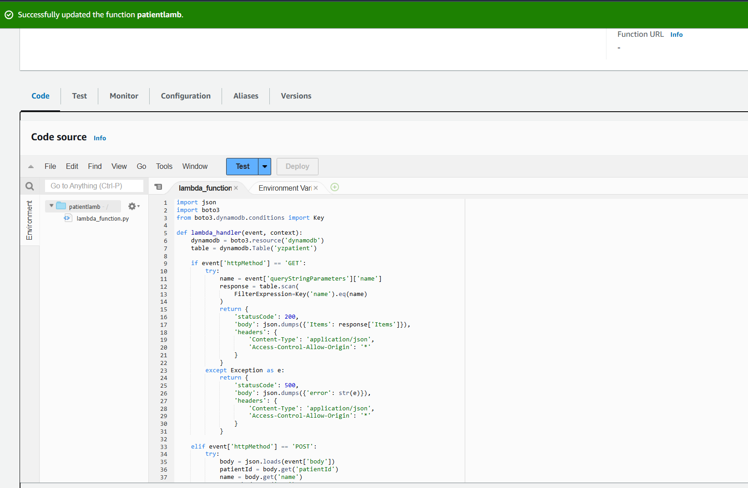

**In this step, you typed JSON code for the Lambda Function. The code includes functionality to process HTTP GET and POST requests. GET requests are used to retrieve patient data based on name, while POST requests are used to add new data to the DynamoDB "yzpatient" table.**

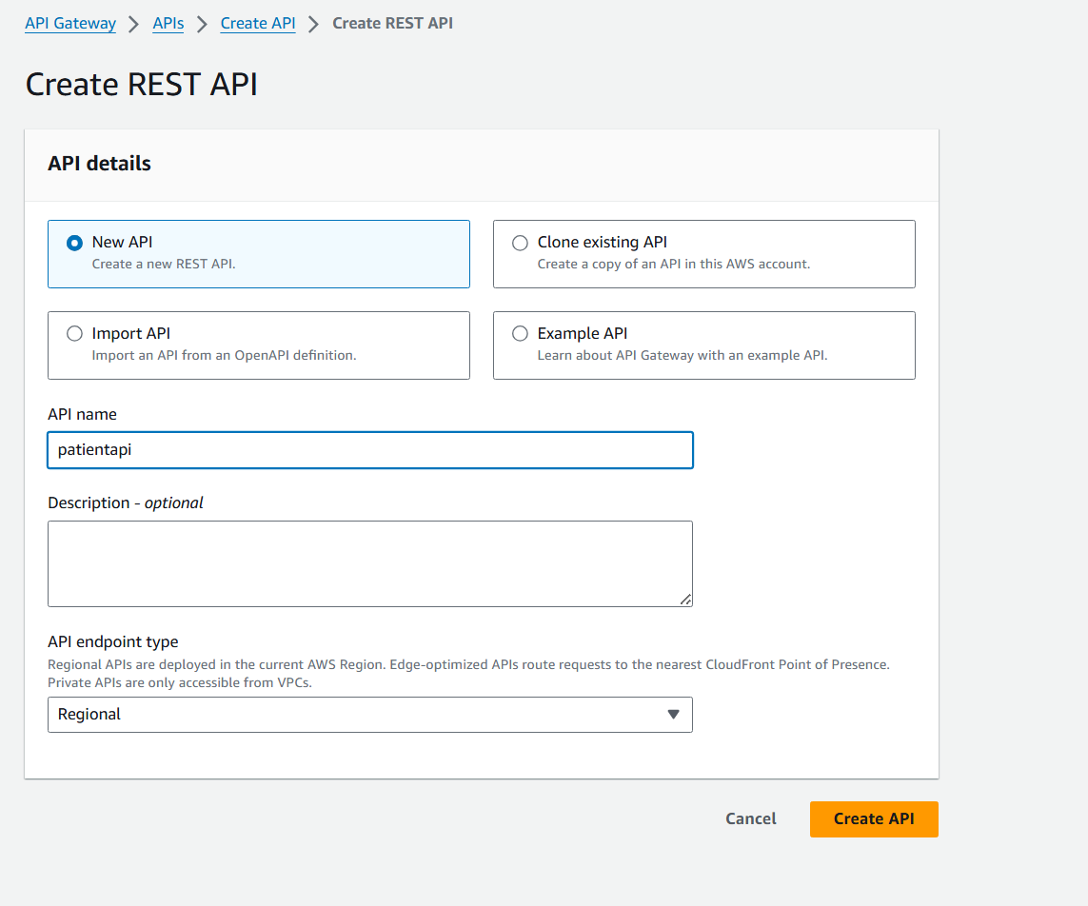

**I created a new API using Amazon API Gateway. In this step, the API is named patientapi. Choose the API type as Regional because it will only be used in the selected region.**

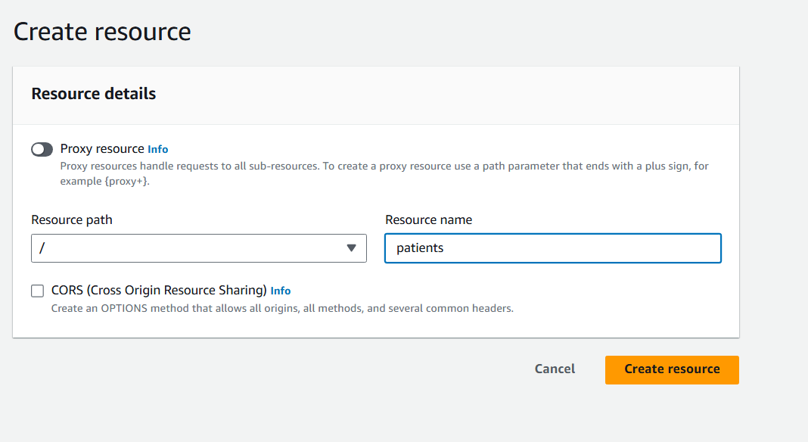

**After you create the API, you create a new resource called Patients. This resource represents the path to be accessed to perform operations on patient data.**

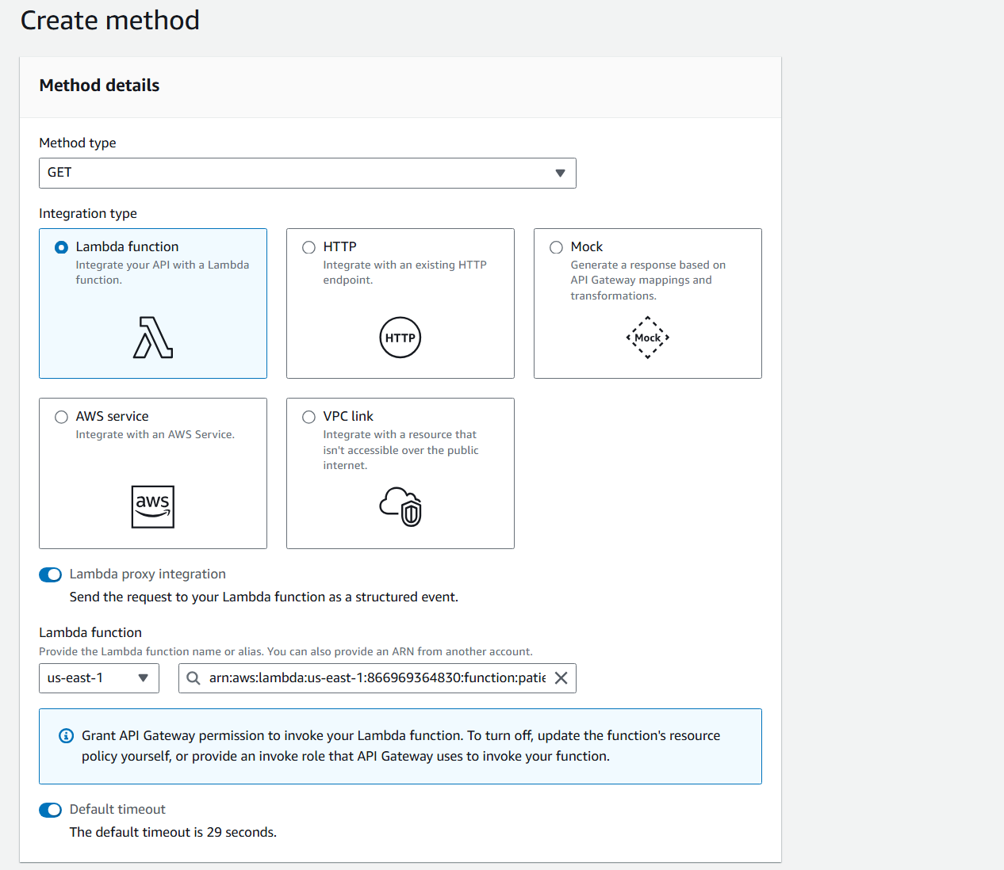

**I added a GET method for the patients resource and made sure it was configured to bind the Gateway API with the previously created Lambda function.**

**I added the POST method for the patients resource and configured it to bind to the Lambda function that handles patient data entry.**

**I enabled Cross-Origin Resource Sharing (CORS) on both GET and POST methods to allow access from different web browsers.**

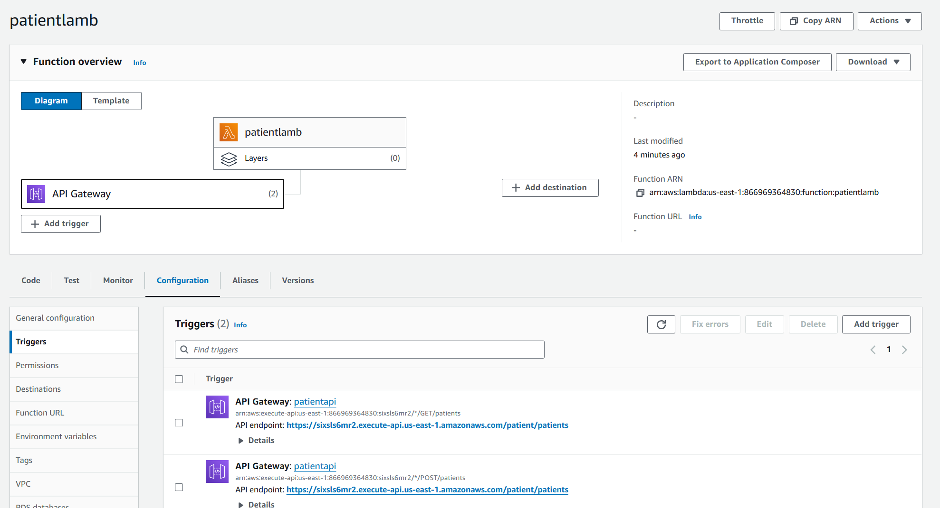

**Make sure that the Lambda function created interacts with the Gateway API correctly. This is done by assigning Lambda permissions to run via the Gateway API.**

**I uploaded static website files to the generated S3 Bucket. This includes the HTML, CSS, and JavaScript files necessary to run the site.**

DynamoDBhere I created 25 patient information within the

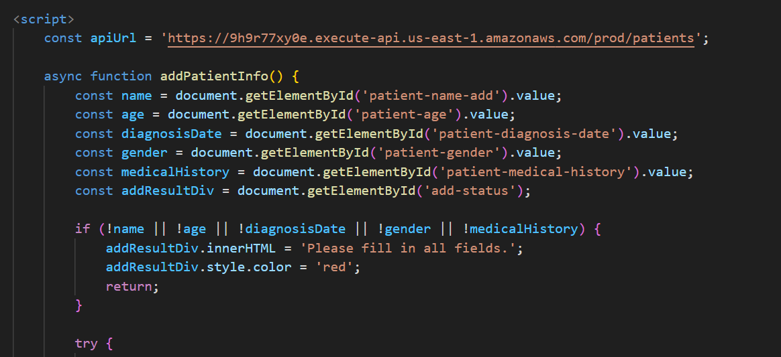

The HTML file has been modified to include a form for adding patient data and another form for data retrieval. The buttons in the interface are bound to JavaScript functions that call the API Gateway to send and receive data. The images show the code that is used to make the form interact with the API, allowing users to easily enter and retrieve data through the user interface.



The system has been thoroughly tested. You enter new patient data via the interface and make sure it is successfully added to DynamoDB. The data retrieval function was also tested using the patient's name to verify that the data was displayed correctly. The images illustrate the successful results of adding and retrieving data, confirming that the system is fully functional and integrated with all AWS services used.

**Q8**

The system development process began with a deep understanding of the strict requirements set by HealthSecure Inc. To protect sensitive patient data, while complying with strict regulations such as the Health Insurance and Accountability Act (HIPAA). These requirements included the protection of personal data, medical records and financial details, while ensuring the privacy and security of data. The focus has been on creating an easy-to-use system that can handle large amounts of sensitive data securely and efficiently, balancing security and ease of use..

**Use AWS services to achieve requirements:**

DynamoDB: I chose DynamoDB to store patient data because of its high capabilities in providing a scalable and distributed NoSQL database. DynamoDB offers built-in security, scalability as needed, and speed of data queries. A yzpatient table was created to store patient information, with the necessary fields such as name, age, diagnosisDate, gender, and medicalHistory, enabling quick and efficient access to the required data. The automatic scaling provided by DynamoDB ensures excellent performance even as data volume increases.

S3 Bucket: S3 was used to store static files such as HTML pages used in the user interface. S3 provides high security, as general access blocking settings are enabled to ensure that there is no unauthorized access to stored data. HTML files have been uploaded to yzpatientb bucket, allowing users to access the user interface securely. Features S3 With its capabilities to deliver web content quickly and efficiently, enhancing the user experience by reducing load time and increasing performance.

**Lambda Functions**: I created a Lambda function named patientlamb, written in Python, to handle various operations such as adding and retrieving patient data. Lambda provides a secure and server-free execution environment, which means no infrastructure management is required. The code used interacts directly with DynamoDB to retrieve or add data based on requests received from API Gateway. This integration ensures a fast and reliable response, while delivering accurate and up-to-date data in real time.



**API Gateway**: API Gateway is set up to facilitate communication between the user interface and Lambda services. I created a new API and linked it to the Lambda function, allowing GET and POST requests to be received from the UI. This integration ensures that all requests are processed securely and seamlessly, while adhering to the required security standards. API Gateway provides an additional layer of security through request validation and access management, enhancing data protection and ensuring the integrity of operations.

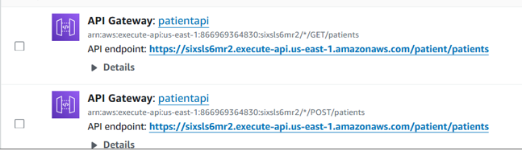

**Fulfillment of security and functional requirements**:

Security High levels of security with S3 and DynamoDB: AWS S3 ensures data encryption at rest and in transit, while maintaining data integrity and confidentiality. DynamoDB provides built-in encryption of sensitive data stored in NoSQL databases, enhancing end-to-end data protection.  
**Fine-grained access control:**  AWS IAM (Identity and Access Management) and access controls ensure that only authorized users and systems have access to specific resources, reducing the risk of unauthorized access.  
Continuous monitoring: AWS CloudTrail monitors API activity, while AWS Config tracks resource configurations, providing real-time visibility into resource actions and enabling rapid responses to security threats.  
**Secure execution of the process:**  Lambda integration and API Gateway ensure that all requests are checked and verified before processing, ensuring the integrity of the system from potential attacks and maintaining data integrity.

**Flexibility and scaling**:   
 DynamoDB and Lambda enable automatic system expansion to handle increased users and data without any manual intervention. This ensures uninterrupted service continuity, while continuously improving system performance. Automatic expansion allows flexible adaptation to workload changes, ensuring high performance and stable system at all times.

**Seamless integration**

**API gateway integration with Lambda and DynamoDB:**

**Efficient operations:** API gateway integration with Lambda and DynamoDB enables efficient execution of operations, providing an interactive user interface for simple and secure patient data addition and retrieval. This integration improves the user experience by delivering fast and reliable service, reducing wait times, and improving overall system efficiency.

**Compliance with laws**:   
 **HIPAA** By applying security and privacy best practices, the developed system adheres to HIPAA requirements, ensuring that sensitive patient data is protected in accordance with applicable legal standards. Compliance with these regulations ensures that all data is treated with the highest level of protection and privacy, which enhances users' trust in the system.

Performance and Compatibility Analysis:

**Efficiency**: Tests show that the system works very efficiently, as data is retrieved quickly and new information is added easily. This ensures an excellent user experience and enhances users' confidence in the system. High efficiency means that the system can handle large amounts of data and multiple requests without any performance degradation, ensuring fast response and smooth operation.

**Reliability**: Tests have proven that the system is reliable and operates continuously without interruptions, with backup and restore capabilities to ensure data protection. Reliability means that the system can operate without interruption even in high-pressure situations, ensuring that all data is available at any time and can be accessed easily and securely.

**Flexibility**: The system can be easily modified and expanded to add new functionality or improve performance, making it a sustainable solution that meets the needs of HealthSecure Inc. Current and future. Flexibility in expansion and development means that the system can adapt to changes in requirements and the technical environment, ensuring that it will remain effective and fit for purpose in the long term.

Thus, it can be argued that the solution developed using AWS services fully complies with the specified requirements, and provides a secure and efficient system for managing sensitive data for patients, while fully adhering to legal regulations and standards. This comprehensive analysis shows that the system not only achieves but exceeds the set goals, boosting confidence in the use of cloud technology for future healthcare solutions.

**Q9**

### A comprehensive analysis of the extent to which the developed solution meets the specified requirements

Monitoring the health and performance of cloud environments is essential to ensure that solutions align with set baseline expectations. For HealthSecure Inc., the implemented cloud relies on AWS services such as Lambda and DynamoDB, and their performance and health are monitored using Amazon CloudWatch. In this section, we will evaluate the basic metrics, monitoring reports, and alert system that has been set up for these services.

#### **مقاييس CloudWatch لـ AWS Lambda**

The first image shows CloudWatch metrics for AWS Lambda. These metrics provide insights into various aspects of the performance and health of the Lambda function:

* **Invocations:** Track how often a lambda function is called. We can see a number of calls in the snapshot displayed, indicating that the function works as expected when making API calls.

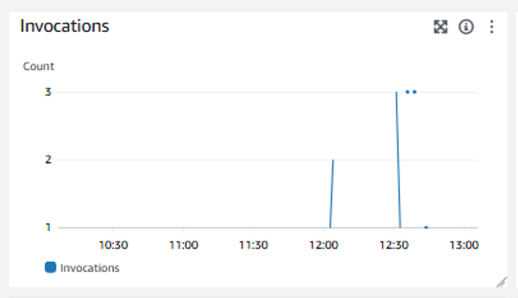

* **Duration:** These metrics measure the execution time of the lambda function in milliseconds. The graph shows the duration for each call, which helps determine if the execution process is taking longer than expected, which may indicate performance issues.

* **Error Count and Success Rate %:** These metrics monitor the number of errors and success rate of lambda job implementations. A high success rate indicates that the job is running without problems, while any errors are highlighted for further investigation.

* **Throttles:** Track how often function execution is determined due to concurrency limits. No selections indicate that the function is running within its limits.

* **Total Concurrent Executions:** These metrics track the number of concurrent executions of the Lambda function. This helps ensure that the functionality does not exceed the concurrency limits set for the calculation

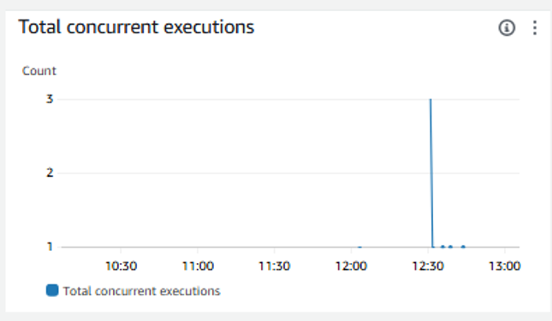

* **Async Event Age and Async Events Received:** These metrics monitor asynchronous calls, providing details about the age and number of events received. These metrics
* Necessary for Lambda functions that run asynchronously, although they appear without data in this case.

* **Async Delivery Failures and Iterator Age:** These metrics monitor issues with asynchronous delivery and redundant lifetime of event sources. Metrics indicate no failures or problems, indicating stable handling of asynchronous operations.

#### **مقاييس CloudWatch لـ DynamoDB**

The second image shows the CloudWatch metrics for the DynamoDB table named "Patients". These metrics are essential to understanding the performance and health of database operations:

* **Read and Write Usage:** These metrics track the rate at which a DynamoDB table is read and written.Graphs refer to custom and consumed units, which helps ensure that the capacity of the table is not decreased or increased.

* **Read and Write Throttled Requests:** These metrics track the number of read and write requests that have been identified due to allocated capacity overflow. Selection can affect application performance, so it's important to monitor and adjust capacity as needed.  
  A white graph with red and black lines

  Description automatically generated

* **Latency Metrics:** These metrics measure the response time of read, write, and scan operations on a DynamoDB table. Low latency values indicate faster response times, which is essential for maintaining a responsive application.

* **Throttled Events and Delivery Failures:** These metrics track the number of events selected and delivery failures. In the snapshot shown, there are no specific events or failures, indicating that the table is running well within its capacity limits.
* **Query latency and async events dropped:** These metrics provide additional insights into the performance of query operations and handle asynchronous events. Monitoring these metrics helps ensure efficient handling of query operations and events.

#### **Evaluate according to baseline expectations**

The metrics and monitoring reports for both Lambda and DynamoDB align with HealthSecure Inc.' s baseline forecast.The system shows stable performance, without major errors or identification problems, indicating that the solution effectively meets performance and scalability requirements. Periodic monitoring and adjustments based on these metrics ensure that the system remains responsive and reliable, providing a robust platform for processing sensitive patient data.

The implemented monitoring and alerting system provides comprehensive insights into the health and performance of the cloud, ensuring compliance with the stringent requirements of HealthSecure Inc. This proactive approach to monitoring and management helps maintain compliance with HIPAA and other regulatory standards, ensuring the security and reliability of patient data. Metrics and detailed reporting provided by Amazon CloudWatch enable continuous assessment and improvement of the cloud, ensuring that HealthSecure Inc. It can provide high-quality and safe healthcare services.

**Q10**

### Accurate examination of network indicators, monitoring report, and alarm system

HealthSecure Inc., a leading healthcare organization that manages huge amounts of sensitive patient data, the effectiveness of records, monitoring reports, and metrics monitoring and alerting systems is critical. Ensuring that these components meet specific requirements and contribute to operational efficiency is critical to maintaining compliance with regulatory standards such as HIPAA and ensuring the reliability and performance of their cloud architecture. This section provides a detailed assessment of these systems, showing their compatibility with the specified standards and enhancing overall operational efficiency..

#### **Records: Ensure traceability and accountability**

#### Implementing **traceability assurance and accountability** through AWS services such as Lambda, API Gateway, andDynamoDB is critical. HealthSecure Inc. must be certain.of recording all related actions and events in detail. This includes user activities, system events, and API calls. By leveraging AWS CloudTrail and AWS Config, they can realize centralized logging and auditing capabilities, enabling effective monitoring, troubleshooting, and compliance auditing. **Improve recording accuracy:** HealthSecure Inc. Improve by enhancing the accuracy of its recording mechanisms. This includes capturing detailed metadata such as timestamps, user IDs, API parameters as well as registration procedures. By enriching records with contextual information, they can facilitate more accurate forensic audits and analysis in the event of security incidents or compliance audits. **Network bottlenecks: selection and impact**

Network bottlenecks occur when data flow within the network is obstructed, resulting in slower performance and potential delays. In the context of HealthSecure Inc. cloud infrastructure., these bottlenecks can significantly affect the accessibility and processing of sensitive data of patients. Potential bottlenecks can arise from limited bandwidth, high latency, or incorrect configuration of network components. Identifying these bottlenecks involves analyzing network throughput, delay, and error rates using monitoring tools such as Amazon CloudWatch. High delays or packet loss can indicate problems that need to be addressed to ensure efficient data flow without interruptions.

HealthSecure Inc. Consider internal and external factors that can contribute to network bottlenecks. Internally, this includes the capacity of an organization's data centers, the performance of switches and network routers, and the efficiency of internal data routing protocols. Externally, factors such as Internet Service Providers (ISP) performance, peer arrangements, and the impact of distributed denial of service (DDoS) attacks must be considered. Regular network audits and stress tests can help identify potential bottlenecks before they affect operations.  
  
**Traffic optimization strategies:** Implementing dynamic traffic shaping algorithms can improve bandwidth allocation based on real-time traffic requirements. HealthSecure Inc. can.Leverage quality of service (QoS) policies to prioritize critical healthcare data transfers over less time-sensitive traffic, thereby reducing congestion and ensuring consistent performance during peak usage periods.

#### **Communication indicators: monitoring and analysis**

Connectivity indicators provide key insights into the stability and performance of network communications. Key indicators include delay, jitter, packet loss, and throughput. Delay measures the time it takes for data to move from one point to another, while dashness refers to varying packet arrival times, which can affect the quality of applications in real time. Packet loss represents the percentage of packets that fail to reach their destination, affecting data integrity and performance. Throughput measures the amount of data successfully transferred across Network. By closely monitoring these indicators, HealthSecure Inc. Identify patterns and anomalies that may indicate underlying issues affecting network performance.

Advanced network monitoring tools can provide more detailed insights into these indicators. For example, using flow-based monitoring technologies such as NetFlow or sFlow can provide detailed information about network traffic patterns, including which applications consume the most bandwidth and where bottlenecks may form. In addition, synthetic monitoring can measure user interactions from different geographic locations, helping to identify regional problems that may not be obvious. From internal control alone.  
  
**Proactive response time monitoring:**  HealthSecure Inc. Proactively monitor latency metrics across different network segments and geographies. They can improve by setting up automated alerts in Amazon CloudWatch to detect and respond to latency spikes instantly. In addition, implementing edge caching through AWS CloudFront or similar CDN services can reduce latency by delivering content closer to end users, enhancing the overall user experience.

#### **Notes from the monitoring review**

A monitoring review of HealthSecure Inc.'s cloud infrastructure shows., using tools like CloudWatch, various aspects of communication that need attention. For example, observing intermittent increases in delays or periods of high packet loss can indicate network congestion or hardware failures. Identifying the root causes of these problems requires careful examination of network logs and performance data. In addition, periods of low throughput may indicate capacity issues, requiring a reassessment of bandwidth allocation and routing policies for the network. These notes are important for maintenance Proactive and ensure optimal network performance.

In addition to CloudWatch, integrating third-party monitoring solutions such as New Relic, Datadog, or SolarWinds can provide a more holistic view of network performance. These tools can correlate network indicators to application performance data, providing insights into how network issues affect end-user experiences. For example, a rise in application response times can be associated with an increase in network delay, helping to identify the source of the problem.

#### **Areas to improve network efficiency**

Based on insights from connectivity indicators and monitoring reviews, several areas for improvement can be identified. First, improving bandwidth allocation can help ease network congestion, especially during extreme usage times. Quality of service (QoS) policies can help prioritize critical graphical traffic, ensuring that core services are not affected by bandwidth limits. Second, maintenance and periodic upgrades of network devices can prevent malfunctions and boost performance. Using switches and modern high routers can reduce Capacity significantly reduces delays and improves productivity.

Furthermore, adopting software-defined networking (SDN) can provide greater flexibility and control over network traffic. SDN allows dynamic adjustment of network configurations based on real-time traffic patterns, improving resource allocation and increasing overall efficiency. In addition, using Network Functions Virtualization (NFV) can reduce reliance on physical hardware, allowing for faster deployment of network services and easier scaling to meet demand.

#### **Improved data transfer protocols**

Another vital area for improvement is the improvement of data transfer protocols. For HealthSecure Inc., ensuring safe and efficient patient data transmission is vital. Implementing advanced protocols such as HTTP/2 or QUIC can reduce delays and improve data transfer speeds by enabling multiplicity and reducing the administrative burden of establishing connections. In addition, optimizing API gateway configurations to handle extreme loads without degrading performance can enhance the performance and reliability of cloud infrastructure.

Transport Layer (TLS) improvements can also play a vital role in enhancing data transfer efficiency. Technologies such as TLS session resumption and early TLS launch can significantly reduce the delays associated with establishing secure connections. Furthermore, using content delivery networks (CDNs) to store and deliver static content near end users can significantly reduce delays and improve user experience.

#### **Mechanisms of redundancy and transition to failure mode**

To ensure continued network availability and stability, it is necessary to implement redundancy mechanisms and go into fail mode. HealthSecure Inc. can. Take advantage of setting up repetitive network paths and failover strategies to automatically redirect traffic if the underlying route fails. This approach reduces downtime and ensures that critical applications remain available even during network outages. Regularly testing these mechanisms through simulated failure scenarios can help identify and address any potential vulnerabilities in the redundancy setup.

Multiple geographic distribution can also promote redundancy. By distributing resources across multiple geographies, HealthSecure Inc. can. Ensure that failures in one area do not affect the availability of services. In addition, using multiple ISPs and leveraging technologies such as Border Gateway Protocol (BGP) for dynamic routing can provide greater flexibility against network outages.

#### **Security considerations**

Network security is another vital aspect that affects performance. You must ensure HealthSecure Inc. Security measures such as firewalls, intrusion detection systems (IDS), and intrusion prevention systems (IPS) are properly configured and do not present unnecessary delays. Regular security reviews and performance tests of security devices can help identify and reduce any performance bottlenecks that are provided by security controls.

Using modern encryption technologies and optimizing VPN configurations can enhance security without compromising performance. For example, using AES-NI hardware acceleration for encryption can significantly reduce the administrative burden associated with securing data in transit. Furthermore, implementing network hashing and microhashing can reduce the impact of security incidents and reduce the area of attack.

#### **Evaluation of monitoring tools and techniques**

To achieve a comprehensive view of network health, HealthSecure Inc. Take advantage of a combination of traditional monitoring tools and modern monitoring technologies. Traditional tools such as Simple Network Management Protocol (SNMP) based monitoring can provide valuable insights into the performance of network devices, while modern monitoring platforms can provide deep visibility into application and network interactions.

Implementing distributed tracking can help identify performance bottlenecks across complex, multi-level applications. By tracking the flow of requests across the system, delays can be effectively identified and addressed. Furthermore, the use of machine learning and AI-driven analytics can help predict potential issues before they affect users, allowing for proactive maintenance and optimization.

#### **Continuous improvement and iteration**

Improving network efficiency is an ongoing process that requires constant monitoring, analysis, and iteration. You must create HealthSecure Inc. A culture of continuous improvement, where performance indicators are regularly reviewed and changes are made based on data-driven insights. This iterative approach ensures that the network evolves to meet changing demands and remains aligned with organizational goals.

Conducting regular performance reviews and comparison with industry standards can help identify areas for improvement. Interacting with network performance experts and participating in industry forums and conferences can provide valuable insights into best practices and emerging technologies.

Checking network bottlenecks, connection indicators, and feedback from monitoring reviews provide valuable insights into the performance and efficiency of HealthSecure Inc' s cloud infrastructure.By addressing identified bottlenecks, improving connectivity indicators, and implementing strategic improvements, HealthSecure Inc. can. Significantly improve the efficiency and reliability of its network. This proactive approach ensures not only the smooth handling of sensitive patient data but also alignment with the organization's commitment to providing first-class healthcare services. Continuous monitoring and improvement will be critical in maintaining a high-performance cloud infrastructure that meets the stringent requirements of HealthSecure Inc.

**Q11**

### Evaluate the effectiveness of records, monitoring reports, and metrics monitoring and alerting system

HealthSecure Inc., a leading healthcare organization that manages huge amounts of sensitive patient data, the effectiveness of records, monitoring reports, and metrics monitoring and alerting systems is critical. Ensuring that these components meet specific requirements and contribute to operational efficiency is critical to maintaining compliance with regulatory standards such as HIPAA and ensuring the reliability and performance of their cloud architecture. This section provides a detailed assessment of these systems, showing their compatibility with the specified standards and enhancing overall operational efficiency..

#### **Records: Ensure traceability and accountability**

Logs are the basis for understanding system behavior, tracking users' activities, and diagnosing problems. For HealthSecure Inc., implementing comprehensive registration mechanisms across AWS services such as Lambda, API Gateway, and DynamoDB is critical.

**Detailed examination of log effectiveness:** Logs provide traceability by recording every interaction with the system, from API calls to database transactions. This traceability is necessary for audit purposes, as it ensures that all actions can be traced back to their source, which is a requirement under the HIPAA. Furthermore, detailed records facilitate accountability by providing a clear record of who did what and when. This is especially important in healthcare settings, where unauthorized access to patient data can have serious legal and ethical consequences.

**Enhance operational efficiency:** Logs contribute to operational efficiency by enabling rapid identification and problem solving. For example, if the Lambda function fails, detailed logs can provide insights into the exact cause, whether it was a software error, an input data issue, or an integration problem with other AWS services. This reduces average resolution time (MTTR) and ensures services are quickly restored, reducing disruption.

**Compliance with specified standards:** Evaluates the effectiveness of records based on their ability to capture detailed and relevant information. For HealthSecure Inc., records must include timestamps, user IDs, actions performed, and the results of those actions. Logs should be stored securely, with restricted access to only authorized personnel. With AWS CloudTrail, HealthSecure Inc. can. Ensure that all API calls are recorded across their environment on AWS, providing a comprehensive view of all activities.

#### **Monitoring reports: providing insights and clarity**

Monitoring reports are essential to gain insights into system performance and identify trends over time. For HealthSecure Inc., these reports provide clarity about the health of their cloud architecture and help with proactive management.

**Comprehensive monitoring report analysis:** Monitoring reports generated by CloudWatch provide a snapshot of system performance, highlighting key metrics such as CPU usage, memory usage, latency, and throughput. These reports help identify trends and patterns, such as increased latency during peak times or a gradual increase in CPU usage that may indicate the need for scaling.

**Contribute to operational efficiency:** By regularly reviewing monitoring reports, HealthSecure Inc. Make informed decisions about resource allocation and capacity planning. For example, if reports show that certain times of the day experience high traffic, the organization can provide additional resources during those periods to ensure smooth operation. This proactive approach reduces the risk of performance degradation and ensures that the system can handle diverse loads efficiently.

**Meet specific requirements:** Monitoring reports must be customizable to meet the specific needs of HealthSecure Inc. This includes the ability to filter data based on specific criteria, generate reports for different time periods, and create dashboards that provide a real view of key metrics. AWS CloudWatch enables the creation of custom dashboards and alerts, ensuring that HealthSecure Inc. She can monitor the metrics that interest her most and quickly respond to any anomaly.

#### **Monitor metrics: ensure performance and reliability**

Metrics monitoring includes tracking various performance indicators to ensure that the system operates within the specified parameters. For HealthSecure Inc., this is key to maintaining the reliability and performance of their cloud architecture.

**Deep assessment to monitor metrics:** Metrics such as response times, error rates, and throughput are continuously monitored to detect any deviations from the standard. By setting up CloudWatch alerts, HealthSecure Inc. can. Get alerts when any metric exceeds a predefined threshold, allowing for immediate investigation and resolution.

**Enhance operational efficiency:** Effective metrics monitoring enables real-time detection of issues, reducing downtime and improving system availability. For example, if API call error rates suddenly rise, relevant teams can be alerted immediately to investigate and resolve the issue before it affects a large number of users. This ensures that the system remains reliable and minimizes disruptions in healthcare services.

**Compliance with operational objectives:** Metrics monitored must comply with HealthSecure Inc.' s operational objectives.For example, ensuring low latency for API calls is critical to providing a responsive user experience. By monitoring this metric and setting appropriate thresholds, HealthSecure Inc. Ensure that its services meet the expected standards of performance. In addition, monitoring the use of resources such as CPU and memory helps optimize costs, as it allows resources to be expanded or decreased based on actual usage.

#### **Alarm System: Proactive Management and Rapid Response**

An effective alert system is crucial for proactive management and rapid response to problems. For HealthSecure Inc., ensuring that alerts are timely, accurate, and actionable is vital to maintaining the reliability and security of the system.

**Detailed analysis of the effectiveness of the alert system:** The alert system must cover all critical components of the cloud infrastructure. This includes setting up alerts for high error rates, resource depletion, security incidents, and any other anomaly that may affect system performance or security. Alerts should be configured to notify the appropriate teams via different channels such as email, text messages, or integration with incident management tools such as PagerDuty.

**Contribute to operational efficiency:** Enable proactive alerts for HealthSecure Inc. Address issues before they escalate. For example, alerts for high CPU usage can prompt the team to investigate and increase resources if necessary, preventing the possibility of slowdowns or outages. Similarly, security alerts can help quickly identify and mitigate threats, ensuring that patient data remains protected.

**Compliance with specific requirements:** The alert system must be flexible and customizable to meet the specific needs of HealthSecure Inc. This includes the ability to set different thresholds for different metrics, configure alert notifications based on severity, and integrate with existing IT Service Management (ITSM) tools to seamlessly manage incidents. AWS CloudWatch Alarms and AWS SNS (Simple Notification Service) provide powerful capabilities for setting up and managing alerts, ensuring that HealthSecure Inc. It can maintain a high level of operational readiness.

#### **Continuous improvement and adaptation**

For HealthSecure Inc., the effectiveness of records, monitoring reports, and metrics monitoring and alerting systems should not be static. Continuous improvement and adaptation are necessary to keep pace with evolving requirements and technological developments.

**Regular review and improvement:** Regular reviews of logging and monitoring settings are essential to identify areas for improvement. This includes assessing the appropriateness and accuracy of logs, the effectiveness of monitoring reports, and the response of the alert system. By conducting periodic reviews and audits, HealthSecure Inc. can. Ensure that these systems continue to meet their needs and adapt to any changes in the operating environment.

**Integrate feedback and best practices:** Integrating feedback from end users and IT staff who interact with these systems can provide valuable insights into areas that need improvement. Additionally, staying up-to-date with best practices and developments in cloud monitoring and logging technologies can help HealthSecure Inc. in strengthening its systems even more. Engaging with the AWS community and participating in related training programs and certifications can provide new perspectives and solutions.

Comprehensive examination of records, monitoring reports, and metrics monitoring and alerting systems demonstrates their vital role in ensuring the operational efficiency and reliability of the HealthSecure Inc. architecture. By aligning these systems with specific standards and continuously improving their effectiveness, HealthSecure Inc. Maintain high standards of performance, safety, and compliance, ultimately ensuring the best possible service to its patients.

### Use AWS in HealthSecure Inc.

#### **Amazon S3**

Amazon S3 was used to store static files and content such as patient images and documents. S3 enables secure and scalable storage, with options to manage access control and ensure encryption to protect sensitive data.

#### **API Gateway**

The Gateway API is configured to create APIs that interact with other AWS services such as Lambda and DynamoDB. API Gateway enables easy APIs to be created, ensures security and monitoring management, enhancing security and efficiency in handling requests.

#### **DynamoDB**

DynamoDB is a NoSQL database that has been used to store patient information. DynamoDB enables fast and flexible storage, with automatic scaling capabilities and high demand management without impacting performance.

#### **AWS Lambda**

AWS Lambda was used to run code without the need to manage servers. Lambda integrates seamlessly with API Gateway and DynamoDB, allowing functions such as adding and retrieving patient data to run quickly and efficiently.

### Compare requirements with work performed

Together, these solutions represent a robust implementation that meets all of HealthSecure Inc' s specific requirements.By providing scalable, secure, and efficient infrastructure, sensitive data protection and HIPAA compliance are ensured, while enhancing operational efficiency and overall user experience.

AWS integration into solutions for HealthSecure Inc. is critical in meeting the complex needs of the organization and effectively achieving its operational objectives.